

**CIT 0573**

**DATABASE MANAGEMENT SYSTEM**

**PROBLEM BASE LEARNING 2**

**“CAR RENTAL SYSTEM”**

STUDENT NAME : MUHAMMAD IKMAL BIN AZMAN (SET19040080)

: WAN HANI SYAFIAH BINTI WAN RADZI (SET19040025)

TRADE : SEMESTER 3 DSET 2 (JULY 2020)

TTO’S NAME : MISS NORULMUBARAKAH

**Table of Contents**

**Problem Statement 3**

**Introduction 4**

**Screenshot ER-Diagram( Crow's Foot) …………………………………………………………………………….. 5**

**Screenshot of Create Table Using SQL Command …………………………………………………………… 6**

**Screenshot of Insert Values Using SQL Command ………………………………………………………….. 9**

**Screenshot of View Values Using SQL Command ……………………………………………………………. 10**

**Screenshot of Update Values Using SQL Command ……………………………………………………… 11**

**Screenshot of Delete Values Using SQL Command ……………………………………………………….. 12**

**Screenshot Create Form & Navigation Form in Microsoft Access ……………………………………. 13**

**Conslusion ………………………………………………………………………………………………………………….... 18**

**References …………………………………………………………………………………………………………………… 19**

# **Problem Statement**

As people mostly use the manual process to do their rental services, it was not the perfect as they wanted. The client of car rental faced these problems:

1. In order to offer cars for rent through car rental, a car owner normally have to come to the nearest agencies office to register car to be rent out.
2. To rent a car through car rental, a prospective renter who is interested in renting a car need to go to the nearest agencies office to register as a client with the agencies.
3. Cars that provide difficulties to rent out are normally advertised in local or national newspaper. It involves a lot of paper work and consumes time.

As following continuing previous project that completed in in Problem Based Learning (PBL) 1, we already solved the problems that customers faced when they need to rent a car with using database management system (DBMS) to manage customer data easily. Soon, as we will get more customer , we need to improve our solutions to boost our system workflow to increase quality and efficiency in our services.

The main objectives for this system are:

1. To create a system that will allow car owner to register their cars online for rent.
2. To establish a system that will allow renter to register and rent cars online.
3. To create a system that can advertise cars for rent online.
4. To create a system that will reduce paper work and consumes less time.

# **Introduction**

A car rental, hire car, or car hire agency is a company or business that rents cars to students and working people for short periods of time, usually these rents start from a few hours to a day. It is often arranged by many branches or businesses (which allows user to return a vehicle to a different or designated location), and especially located near collage, university, or busy city. Car rental agencies primarily serve people who require a temporary vehicle, for example, those who do not own their own car, travellers who are out of town, or owners of damaged or destroyed vehicles who are awaiting repair or insurance compensation.

Car rental online system is one of the newly developed systems. It is specializing in Car rental services and other services that are related to either the owner or the renter. This system has been created for the role of car rental to act as an intermediary between two clients, namely the car owner and the renter. Anyone who has the interest to rent will not have to register, he or she can have a full access to this system. This system is here to give the best services to the clients and make ensure they get their things to happen as they wanted.

As the owner of a car, you need to register your car that you want to rent out with the company. During the registration, all the details or information about the car will be fully given. As a renter, you also need to register and then search for the desired car you want to rent and the system will check for available car with the same match.

**SCREENSHOT ER Diagram (Crow’s Foot)(From PBL1)**

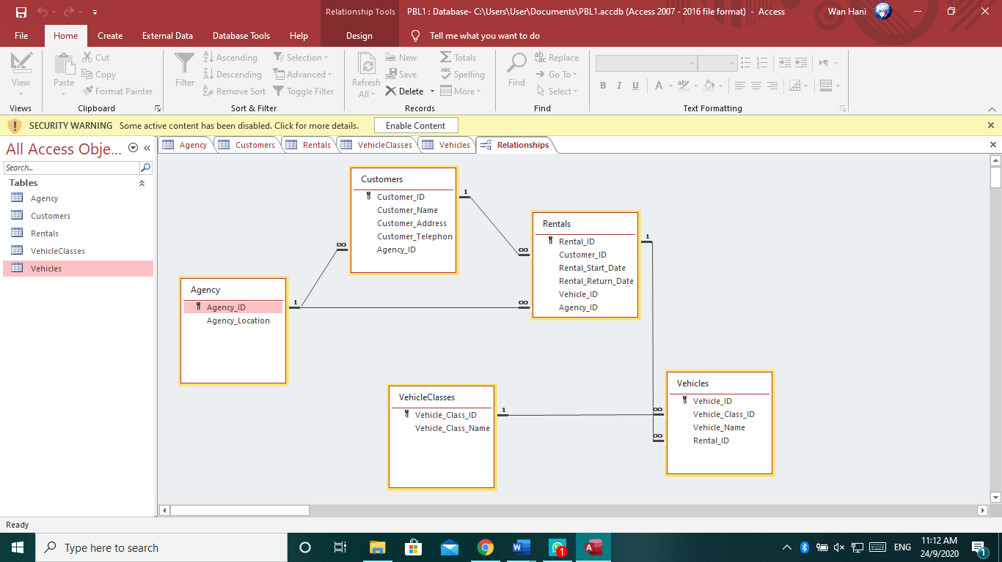

**Screenshot of Create Table using SQL Command**

1. **Agencies**

* **SQL Command**

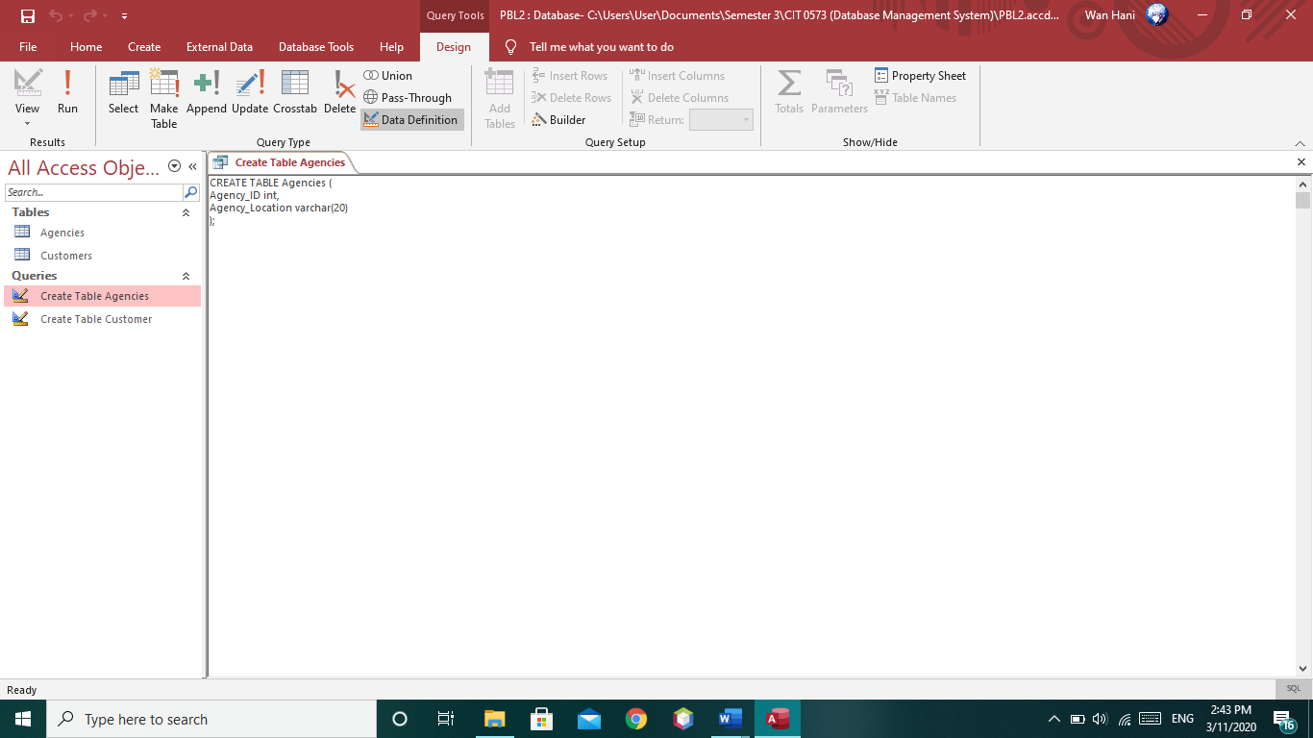

* **Result**

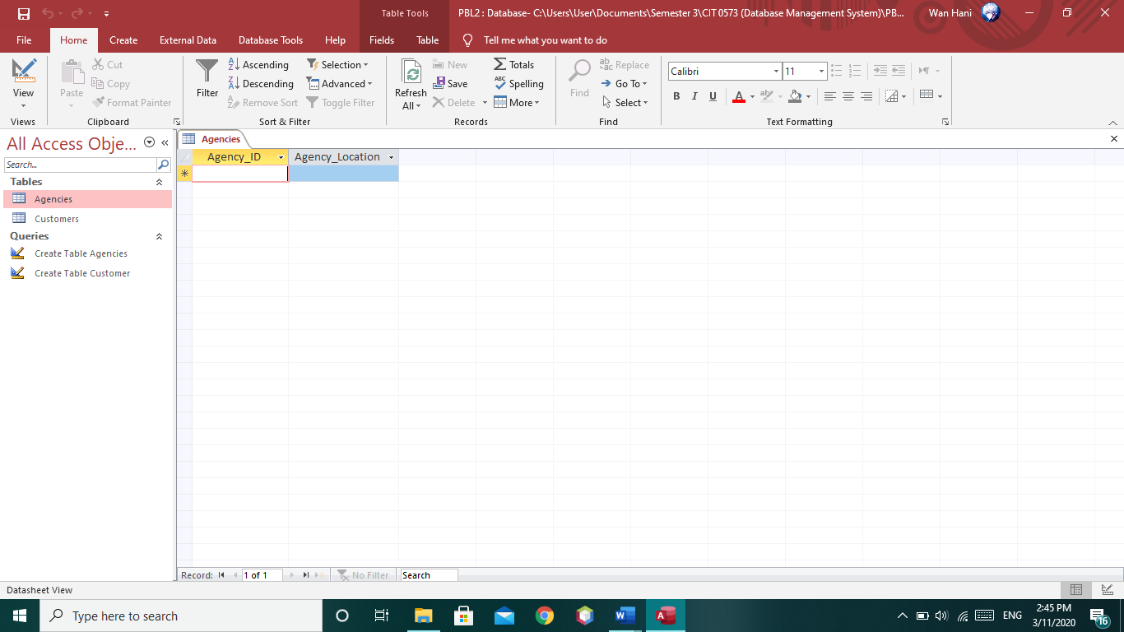

1. **Customers**

* **SQL Command**

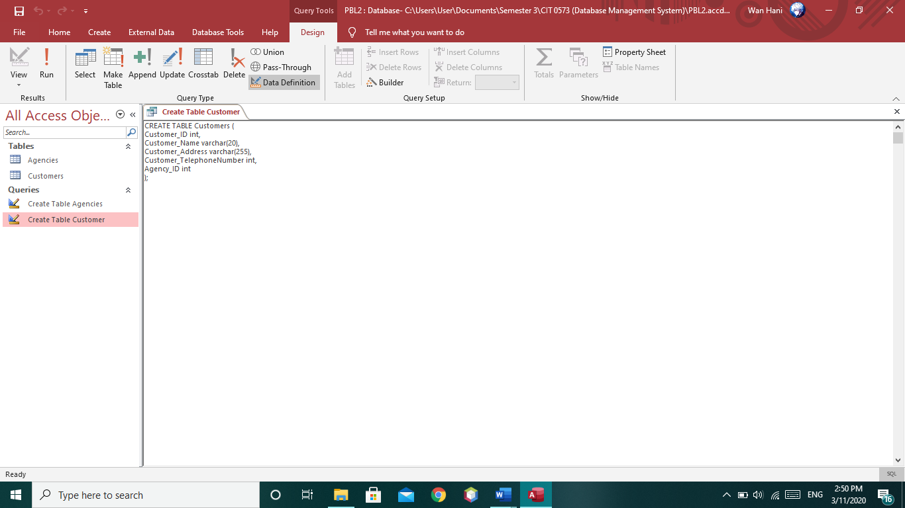

* **Result**

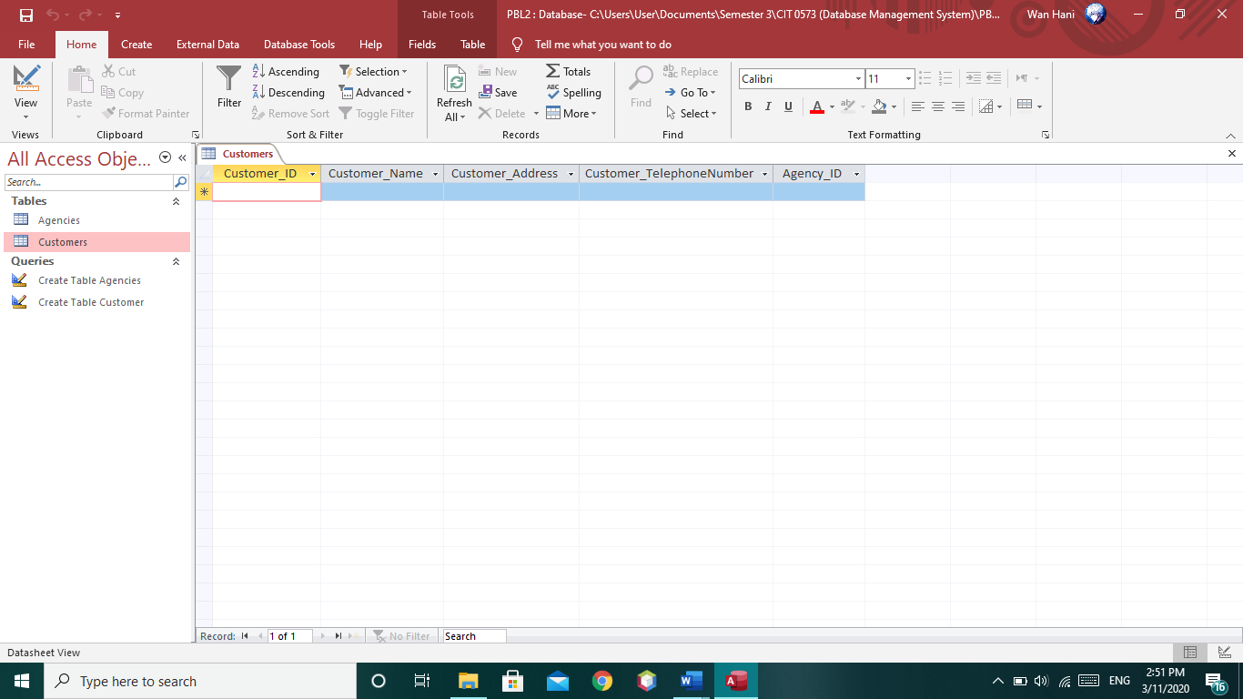

1. **Rentals**

* **SQL Command**

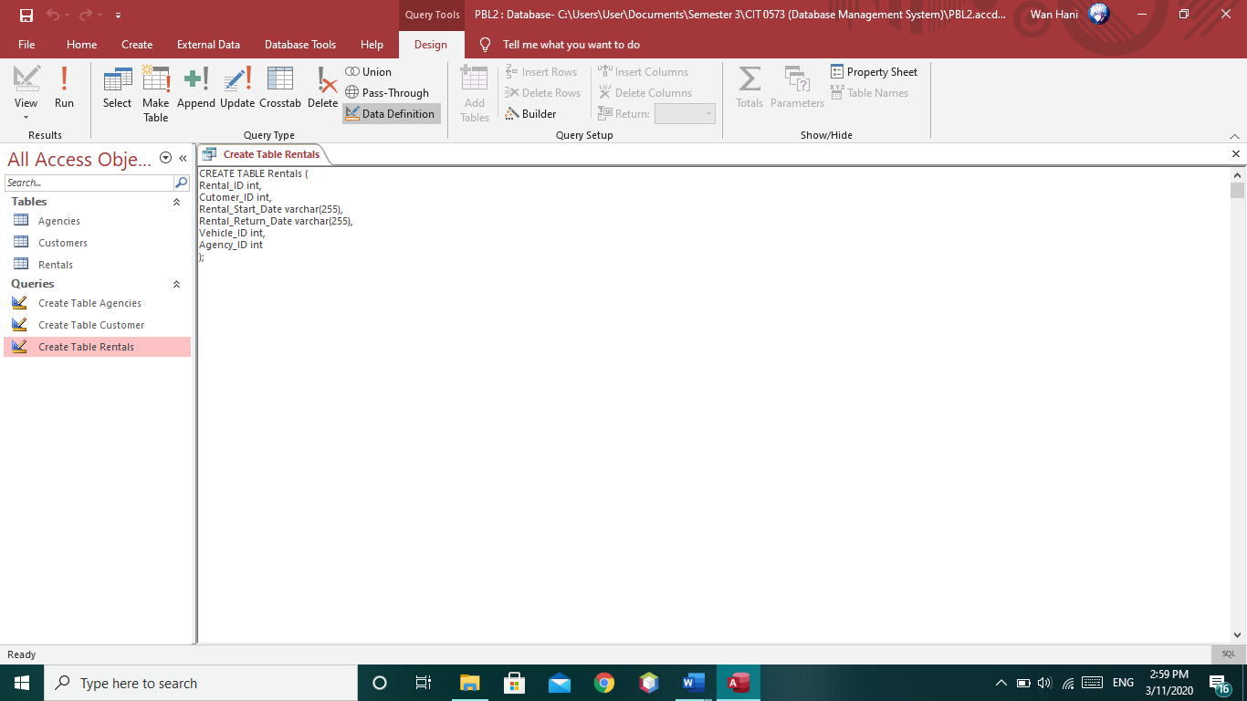

* **Result**

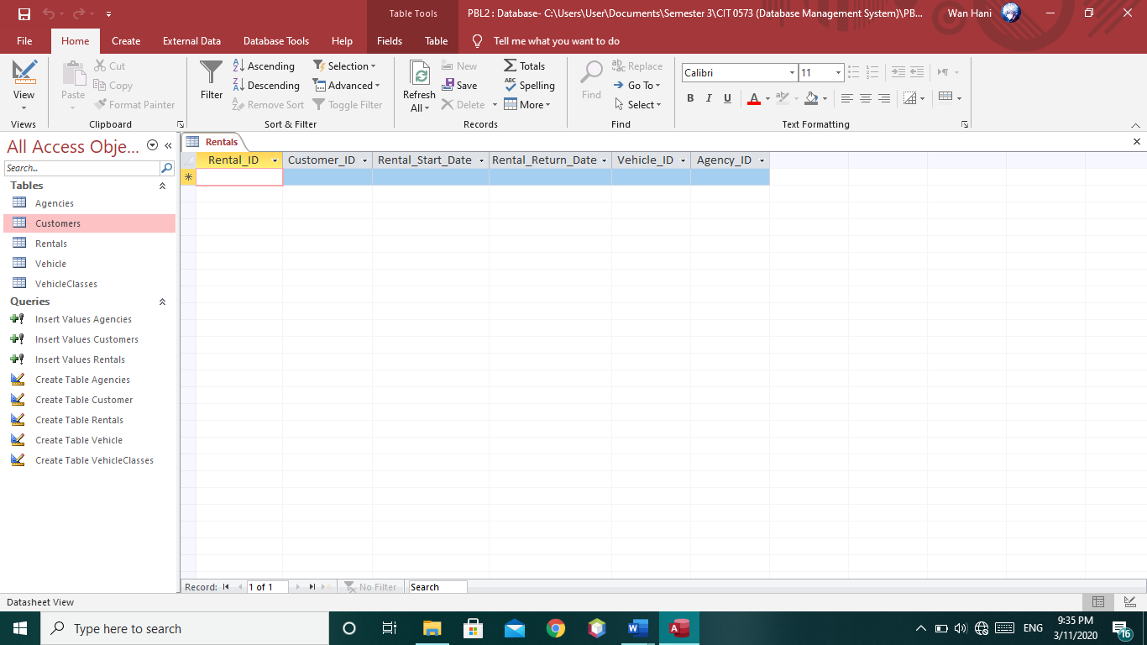

1. **VehicleClasses**

* **SQL Command**

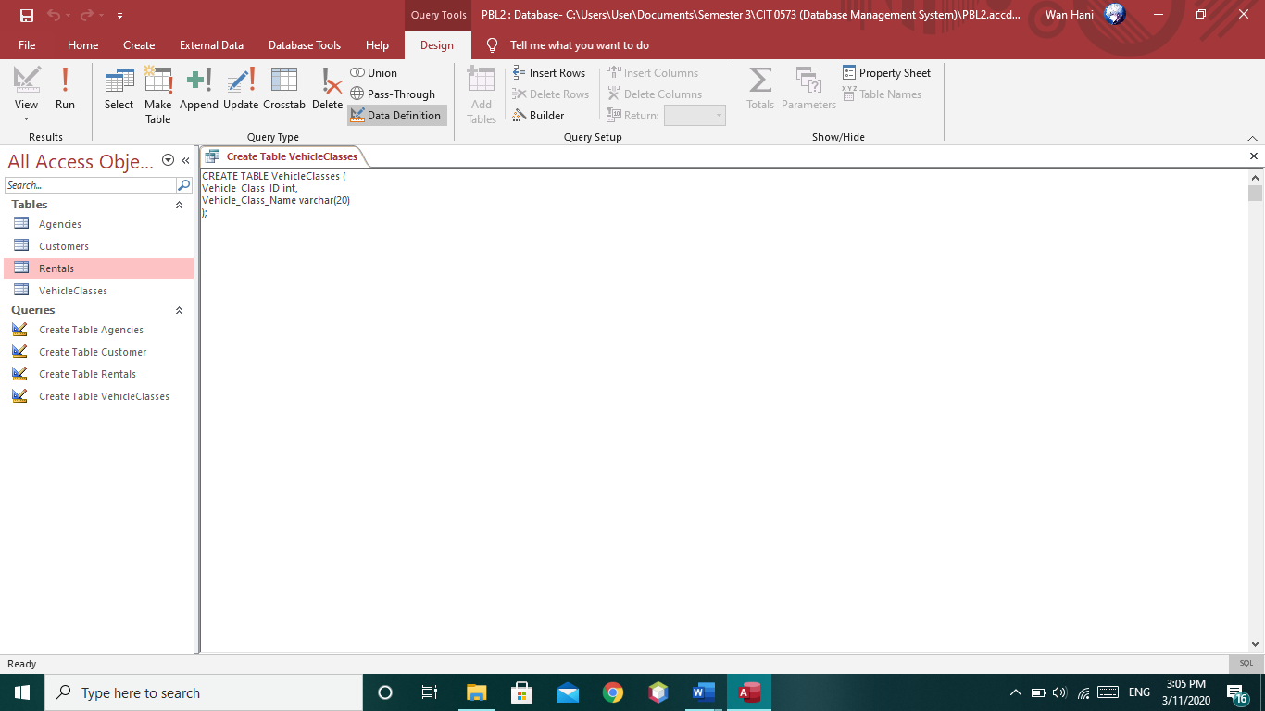

* **Result**

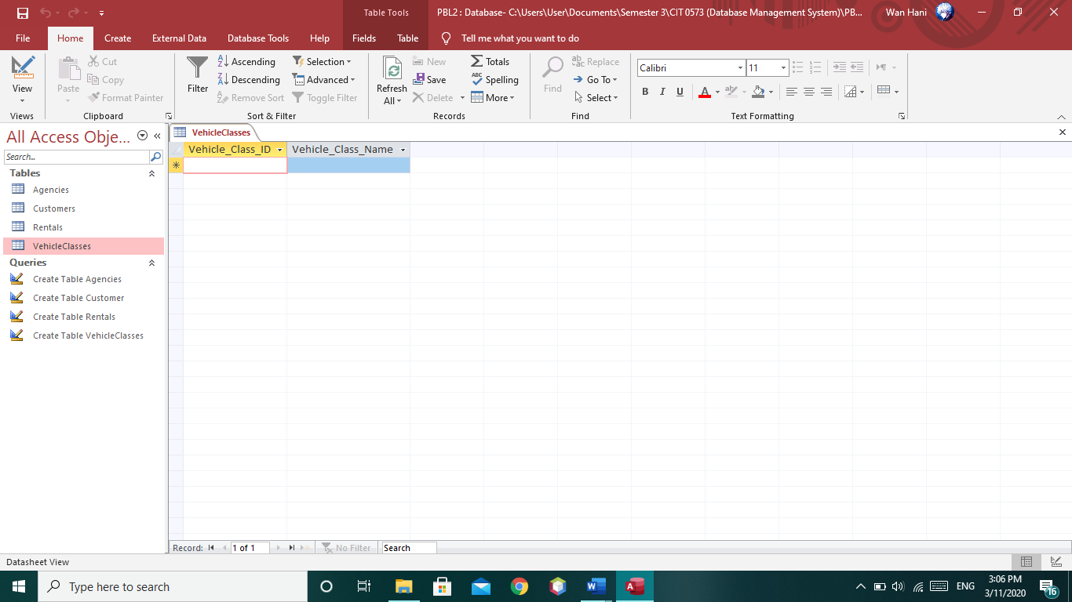

1. **Vehicle**

* **SQL Command**

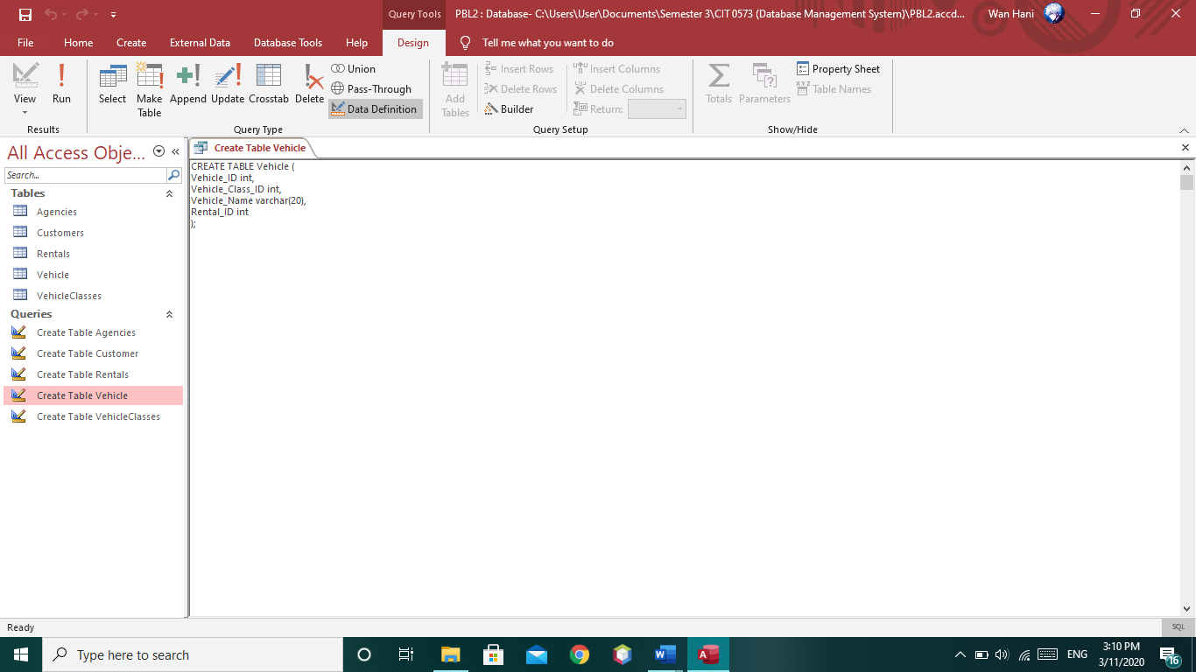

* **Result**

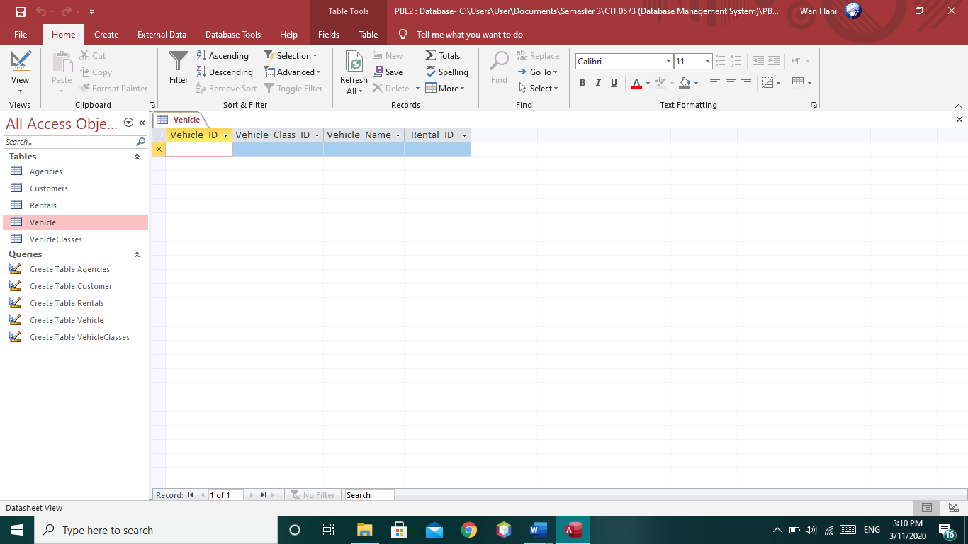

**Screenshot of Insert Values using SQL Command**

1. **Agencies**

* **SQL Command**

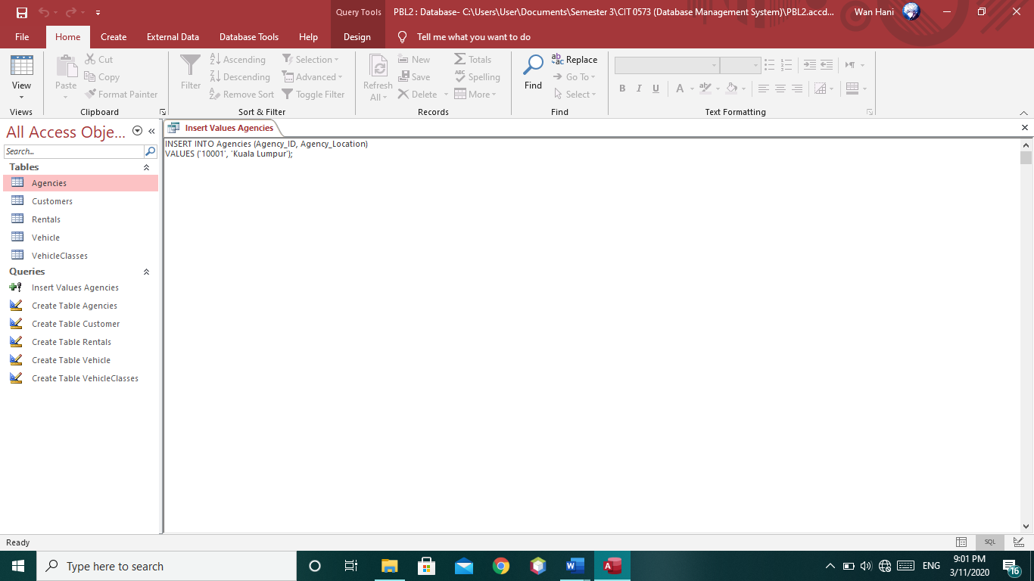

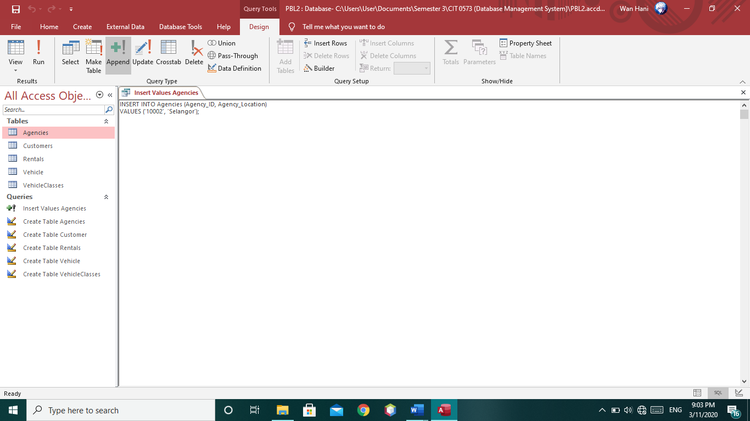

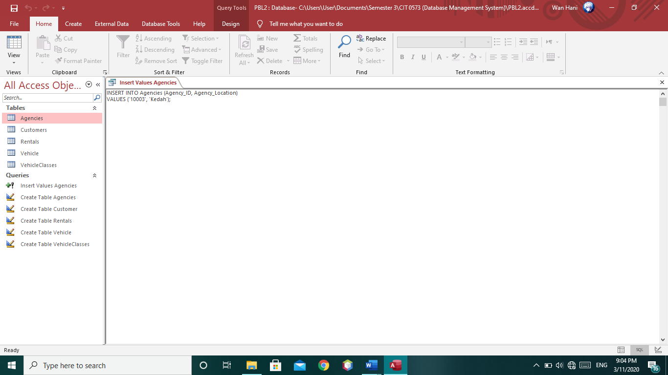

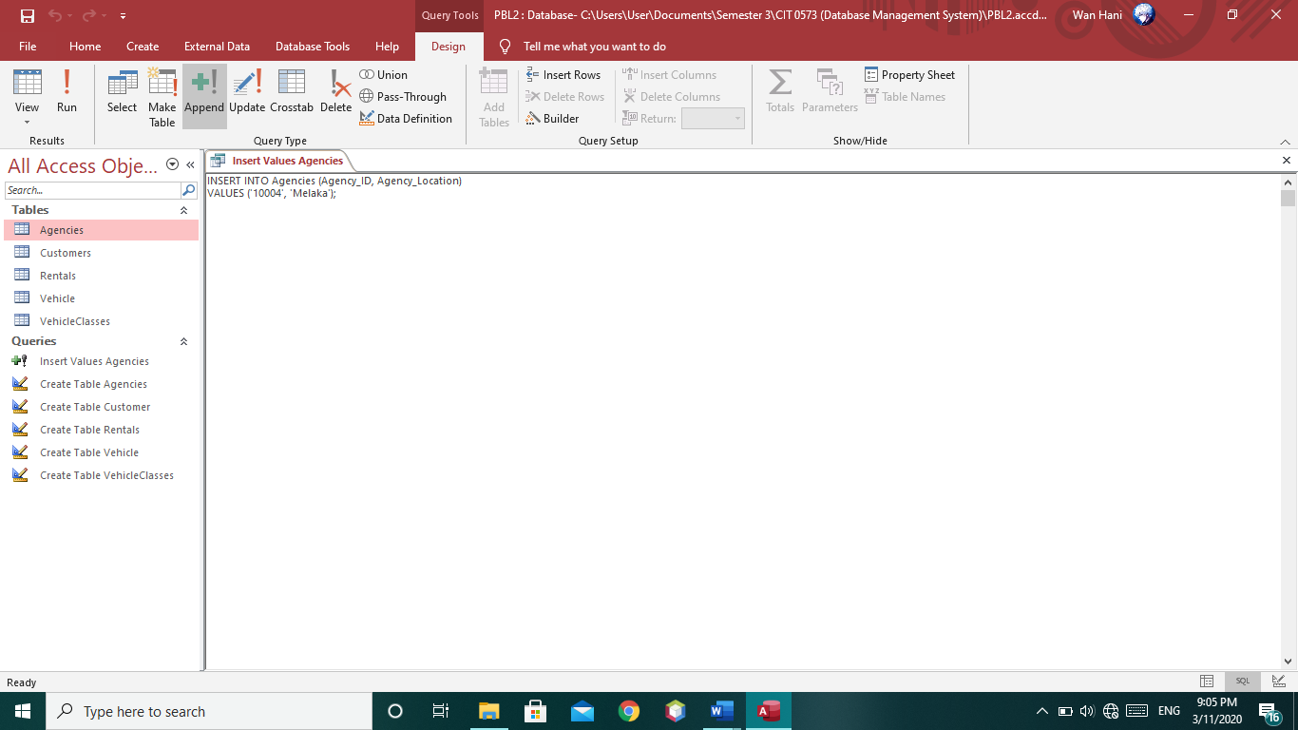

* **Result**

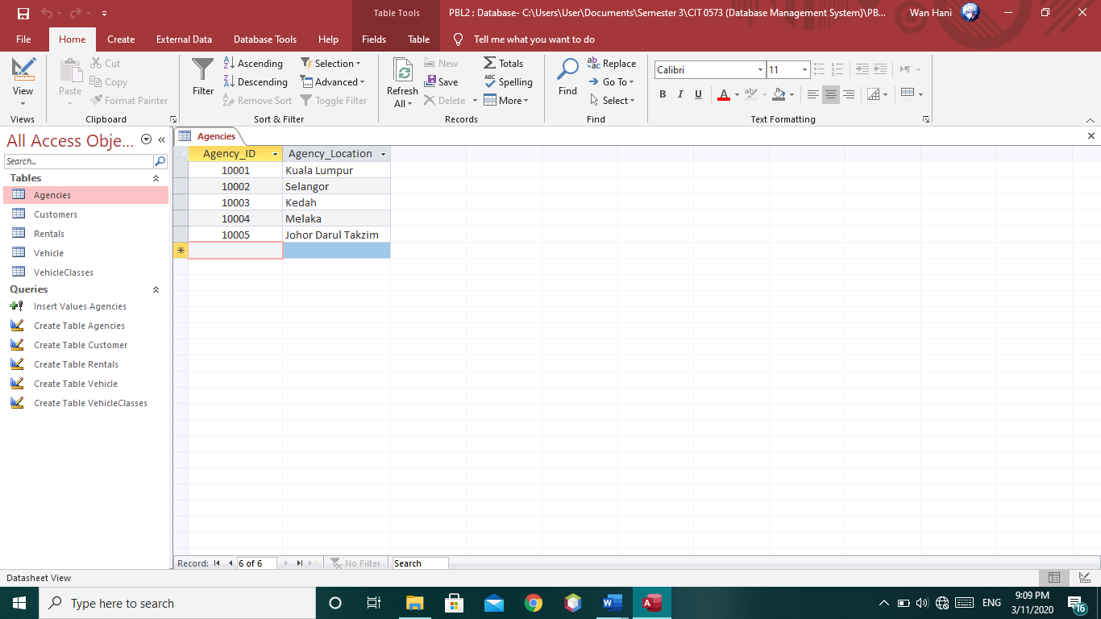

1. **Customers**

* **SQL Command**

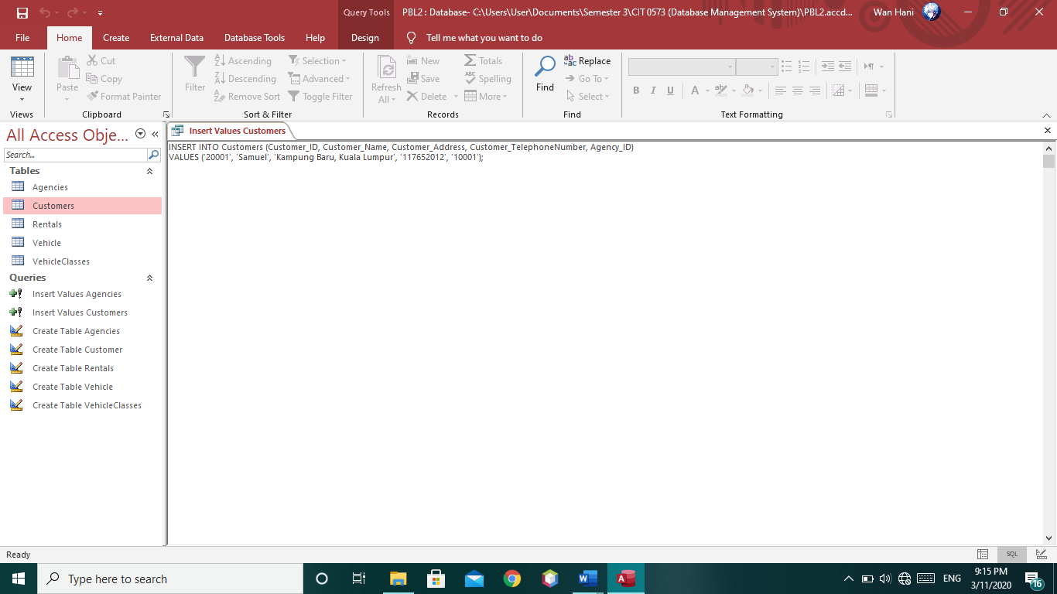

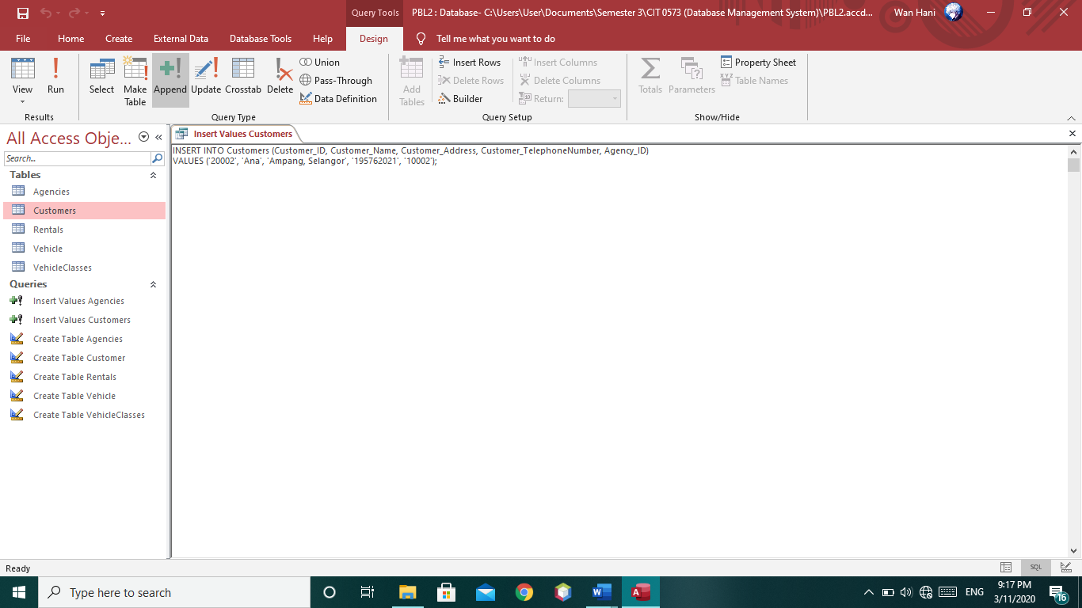

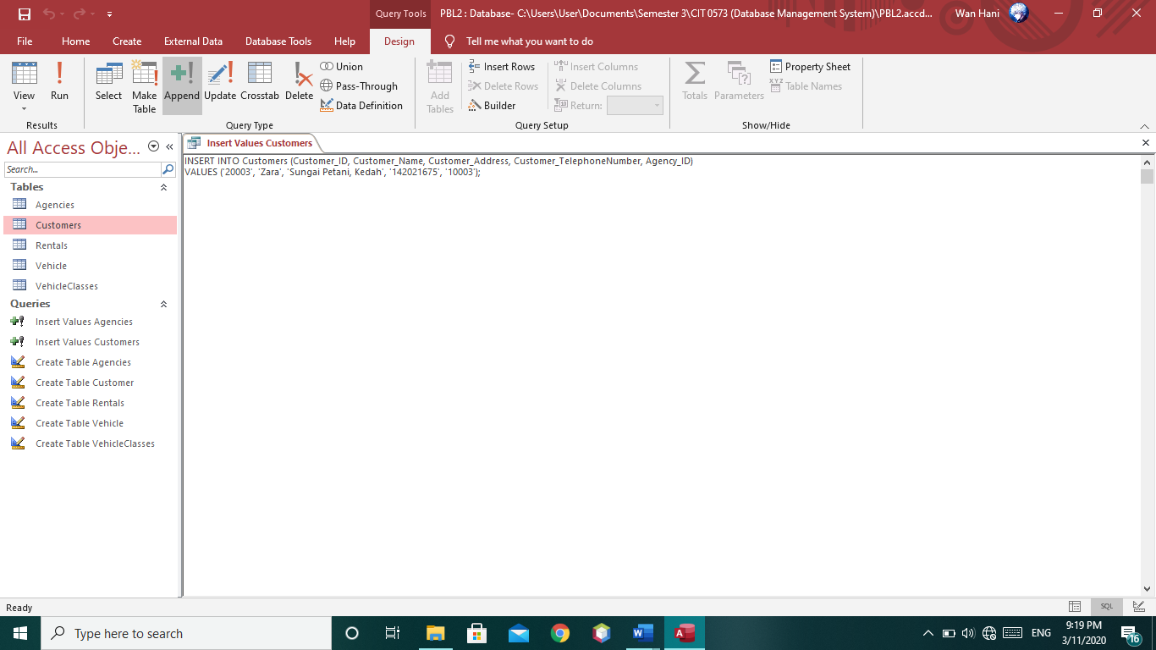

* **Result**

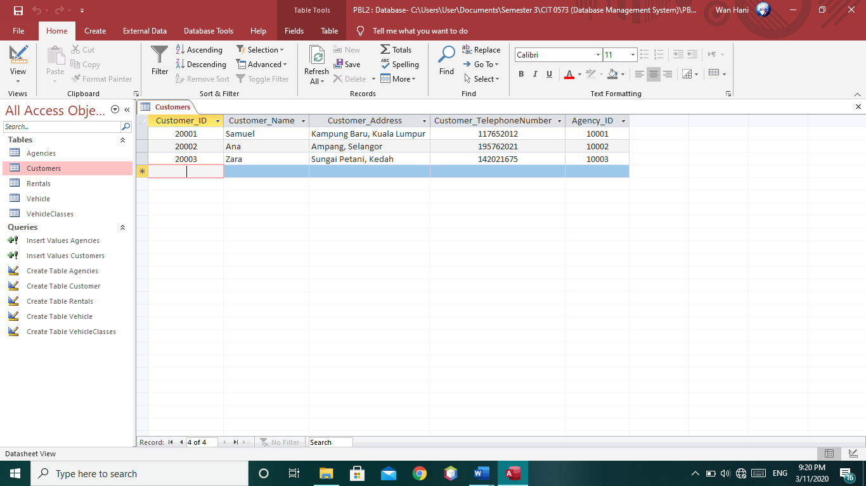

1. **Rentals**

* **SQL Command**

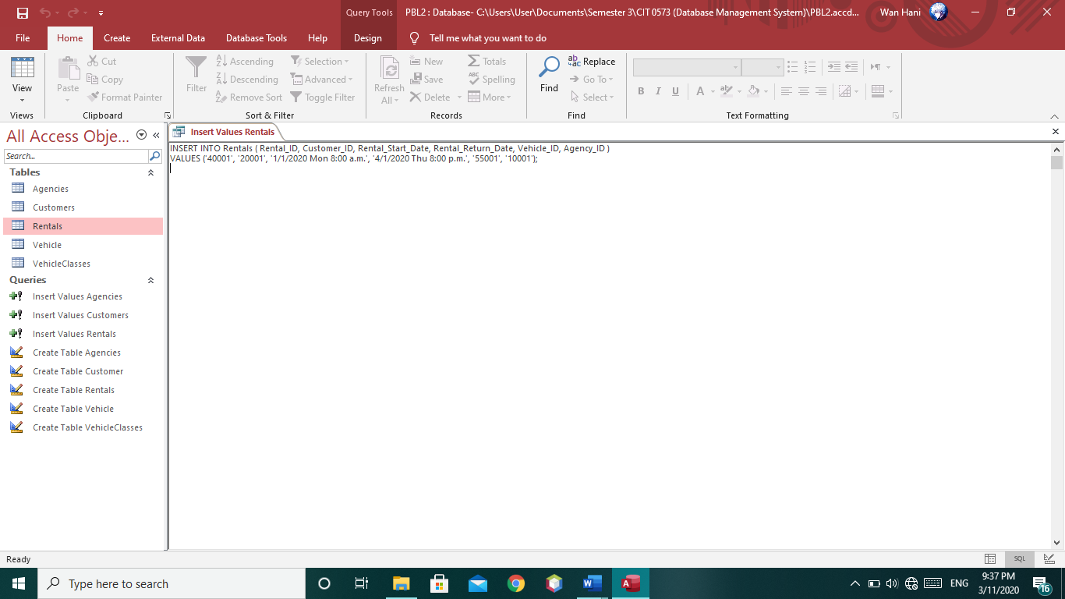

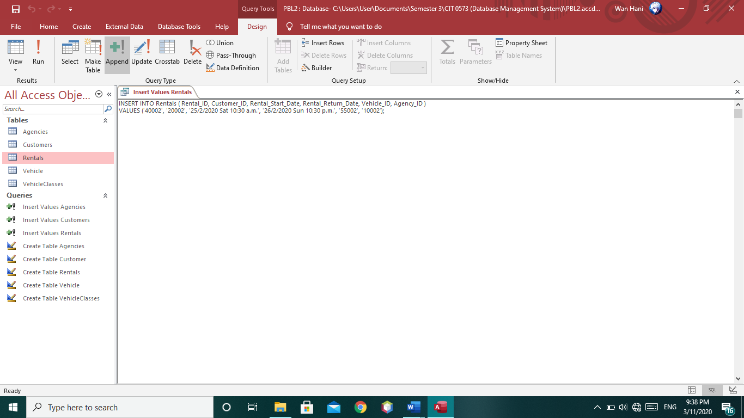

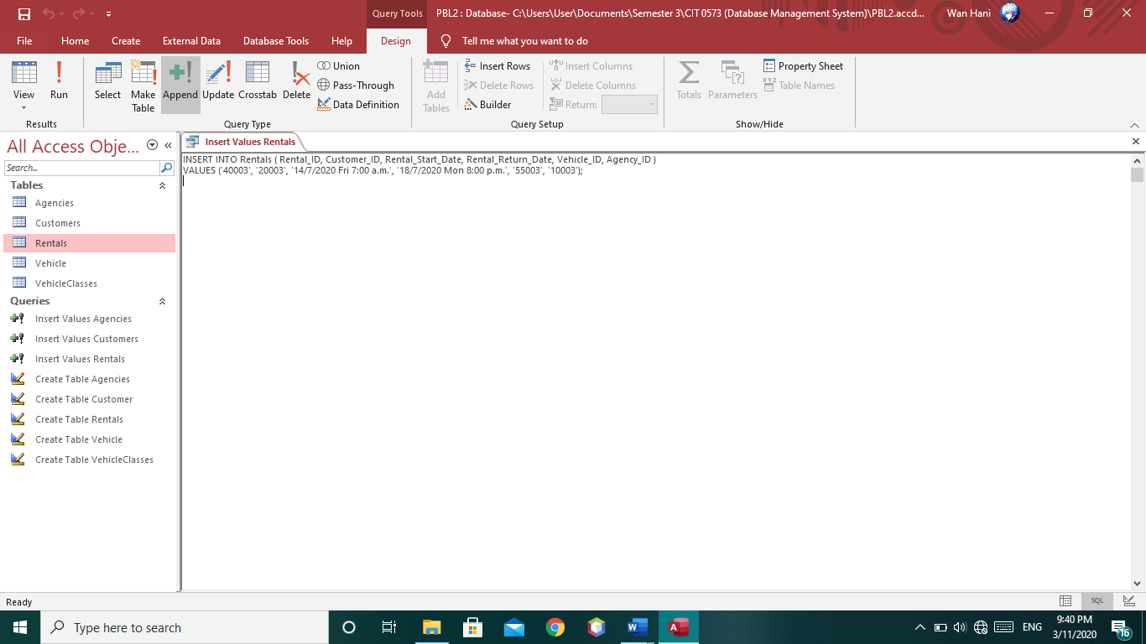

* **Result**

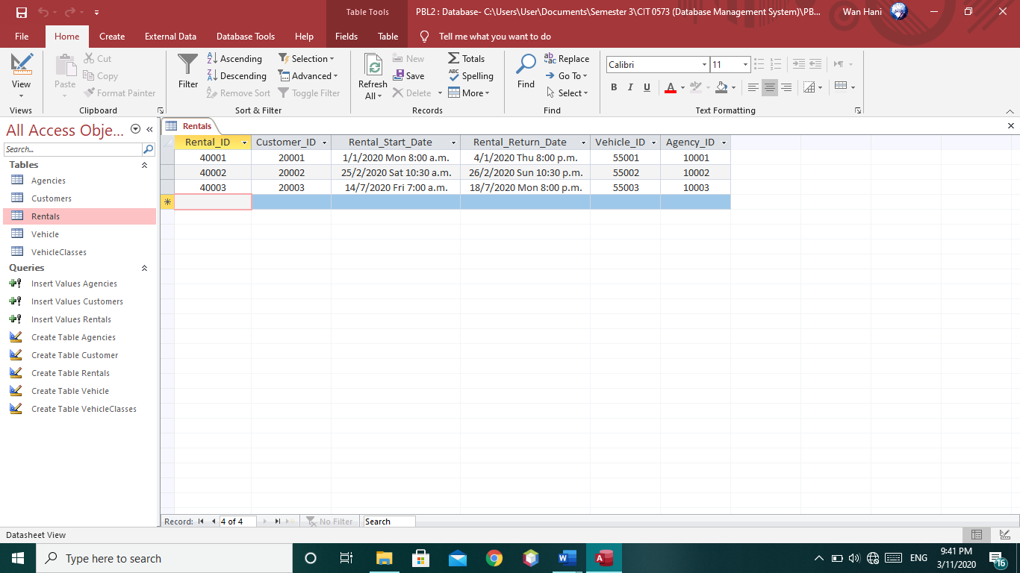

1. **VehicleClasses**

* **SQL Command**

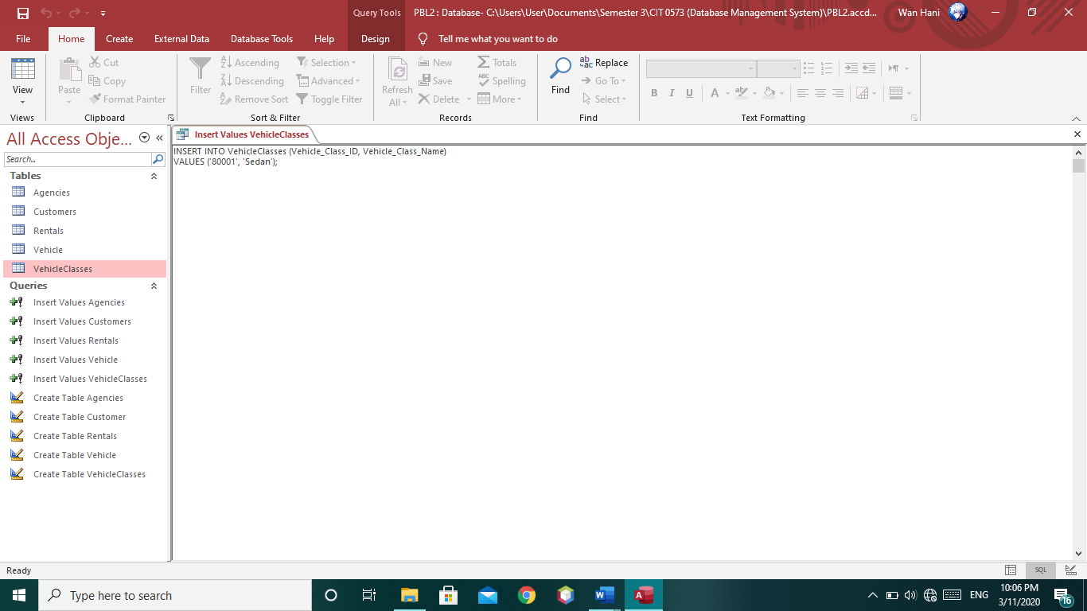

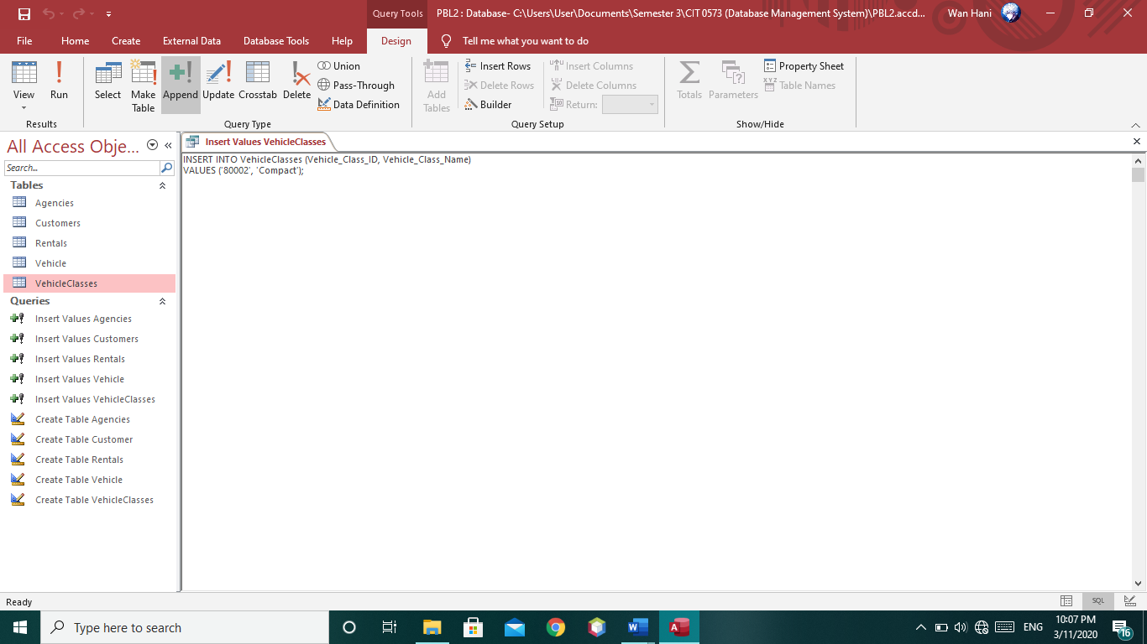

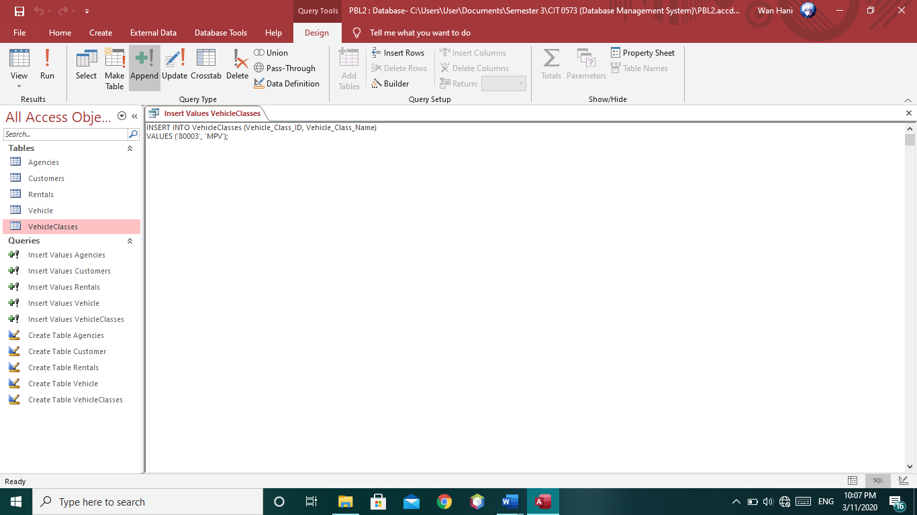

* **Result**

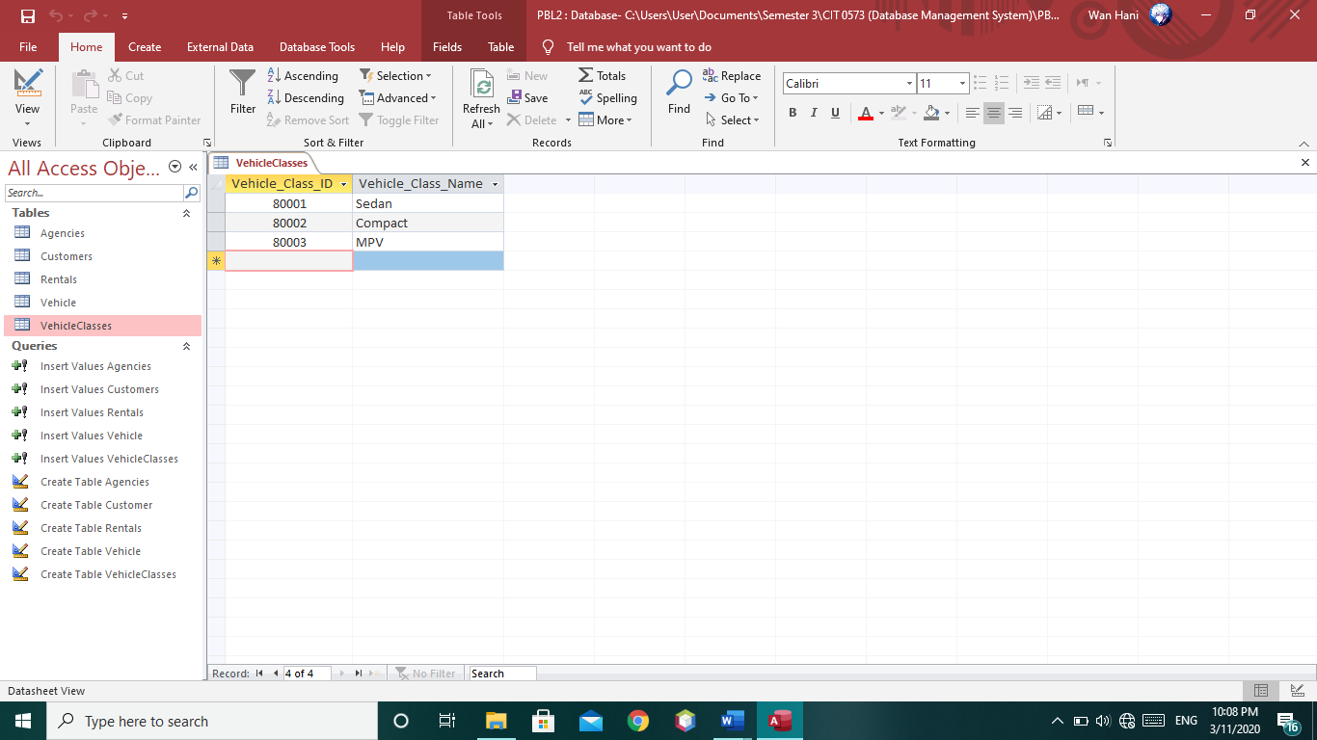

1. **Vehicle**

* **SQL Command**

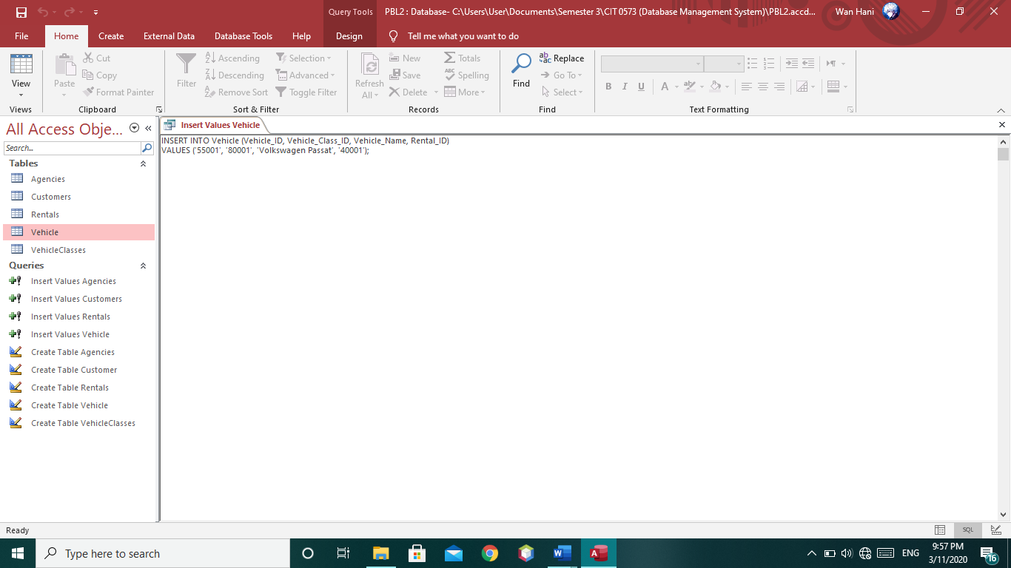

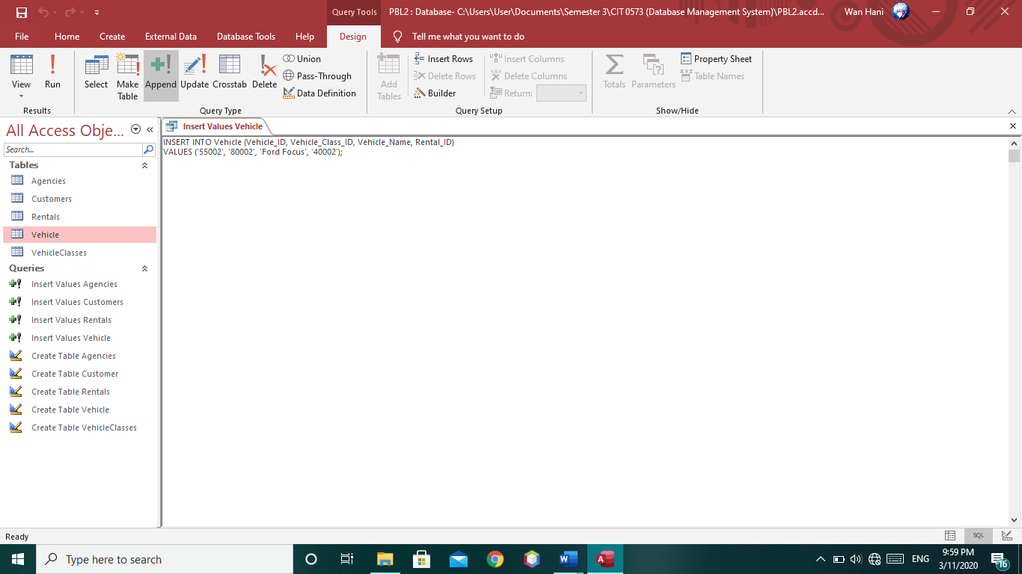

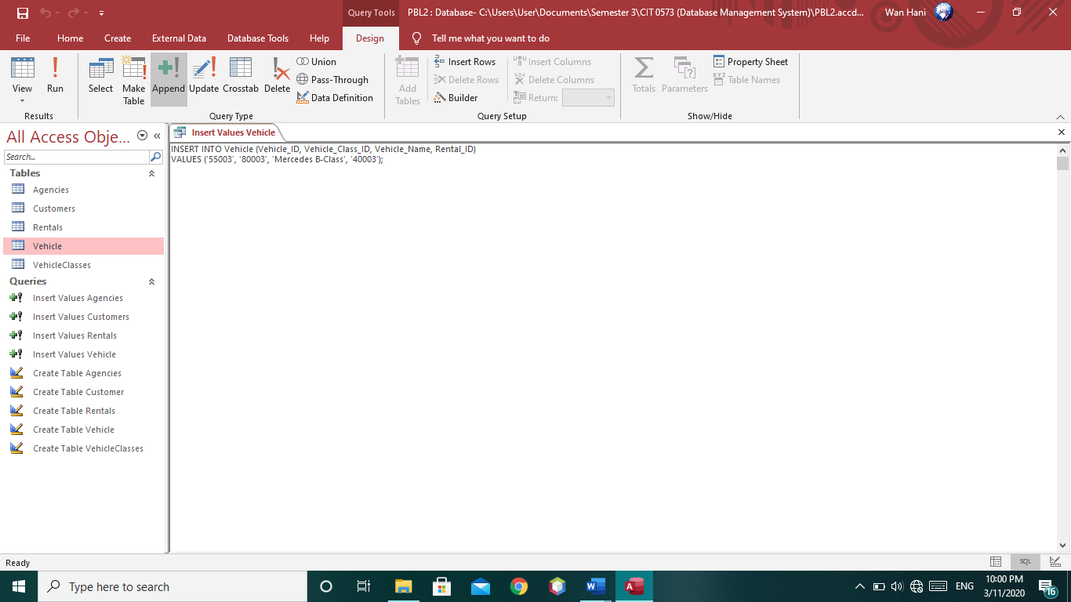

* **Result**

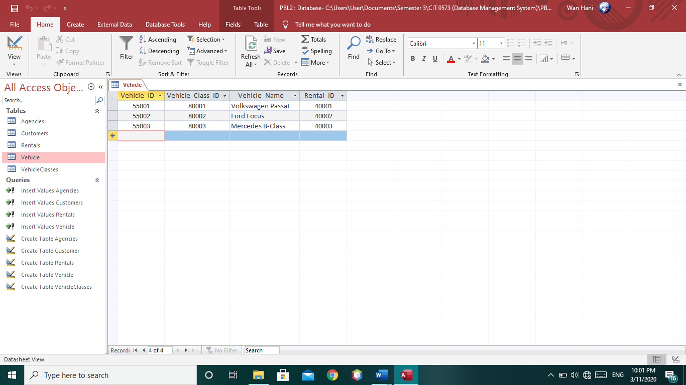

**Screenshot of View Values using SQL Command**

1. **View All Columns in Agency Table**

* **SQL Command**

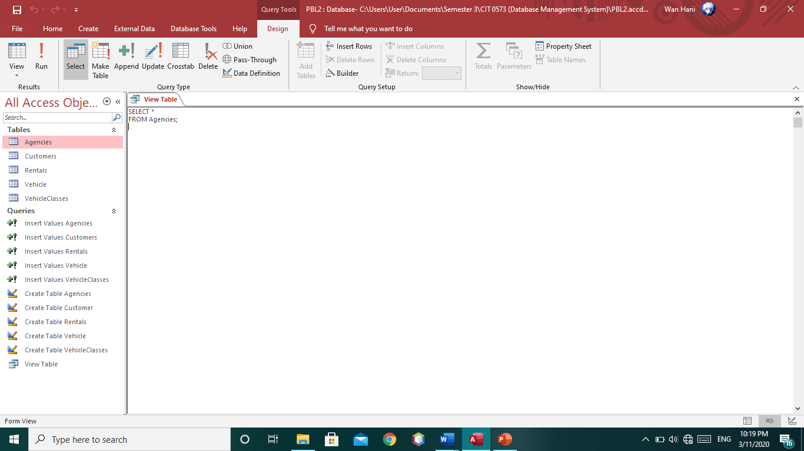

* **Result**

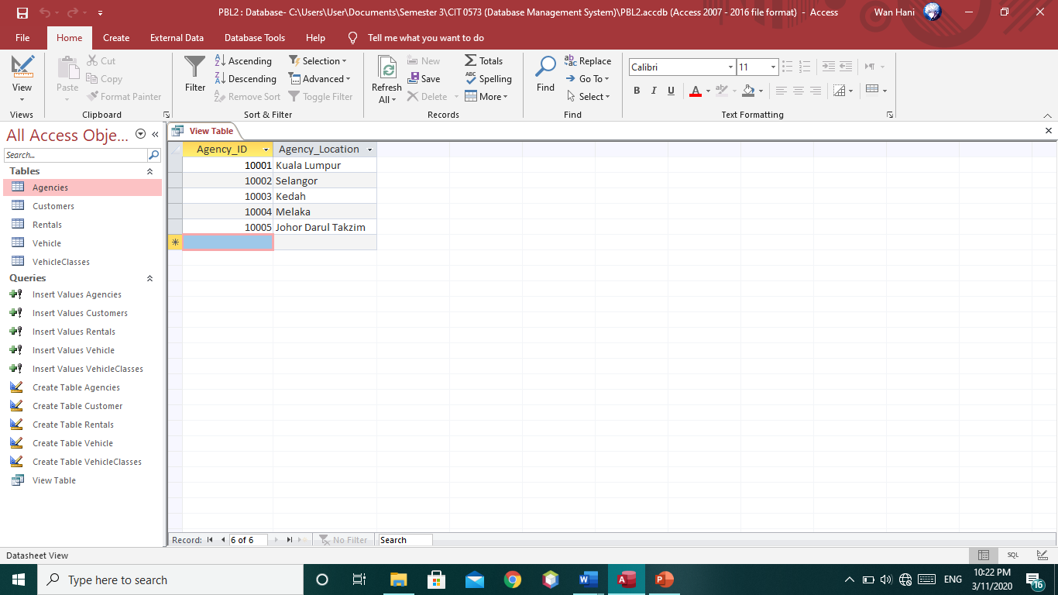

1. **View Selected Column in Agencies Table**

* **SQL Command**

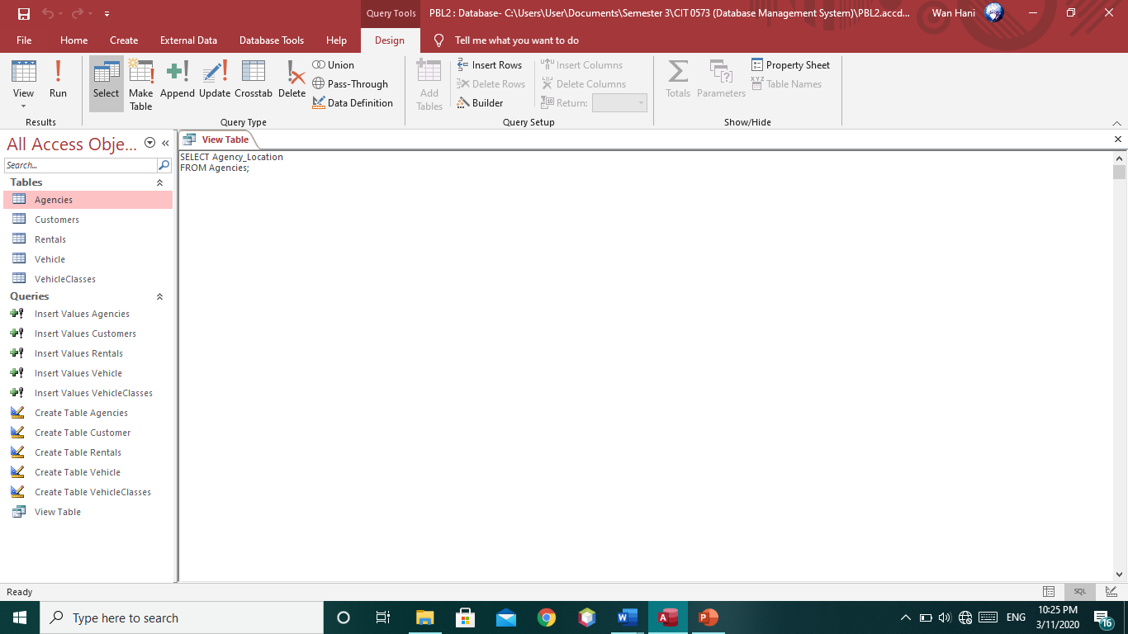

* **Result**

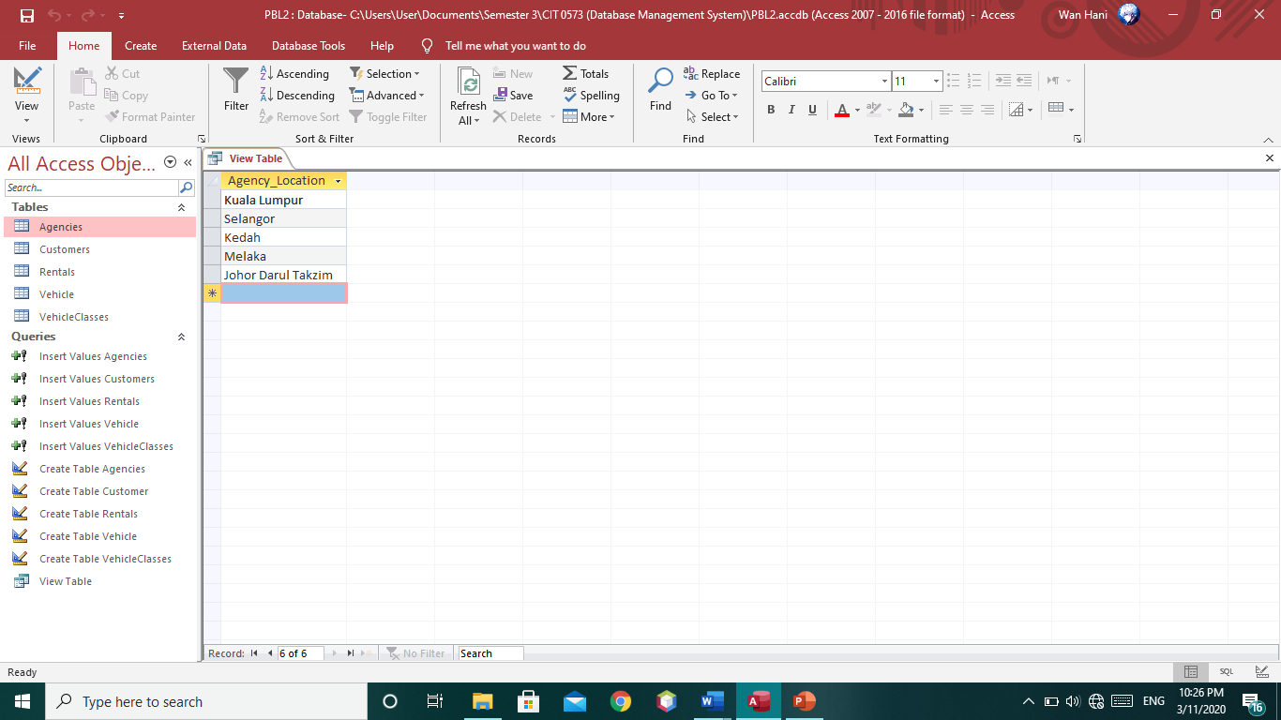

**Screenshot of Update Values using SQL Command**

1. **Update New Data in Customers Table**

* **SQL Command**

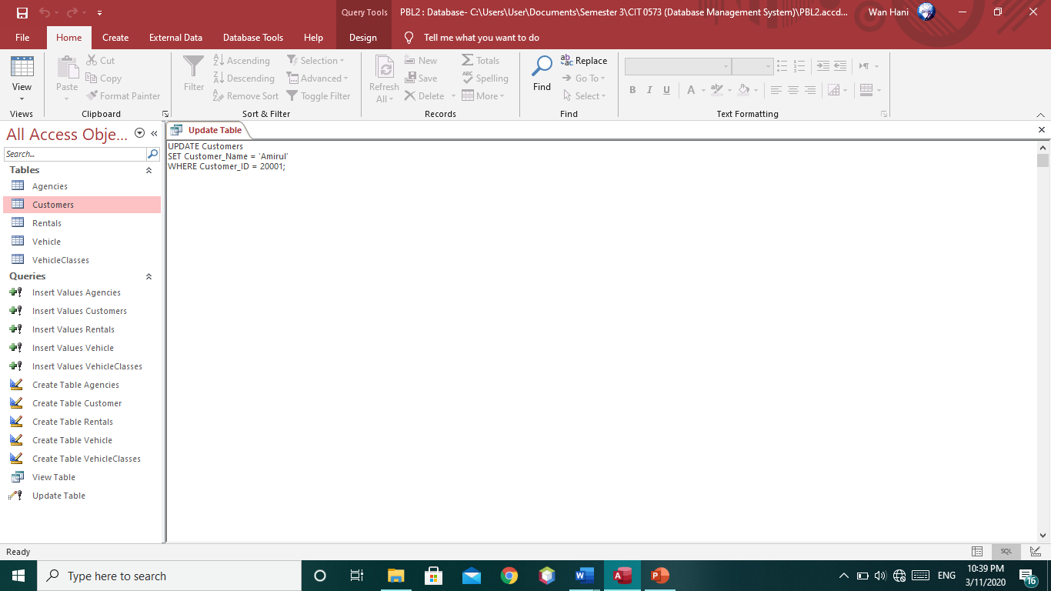

* **Result**

**Before :**

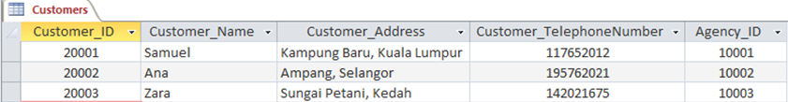

**After :**

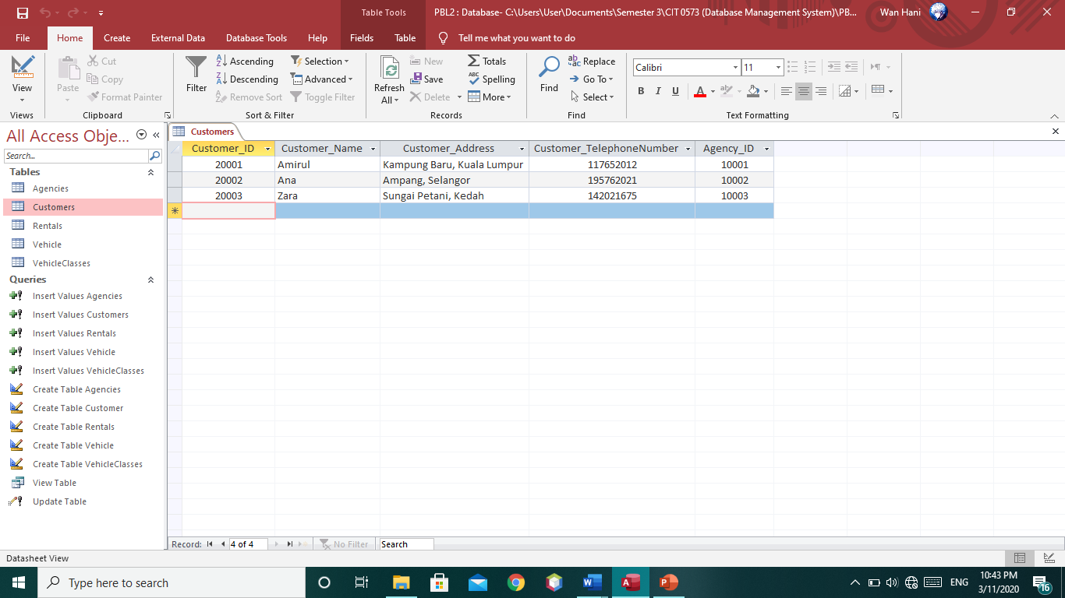

**Screenshot of Delete Data using SQL Command**

1. **Deleting Data in selected row in Vehicle table**

* **SQL Command**

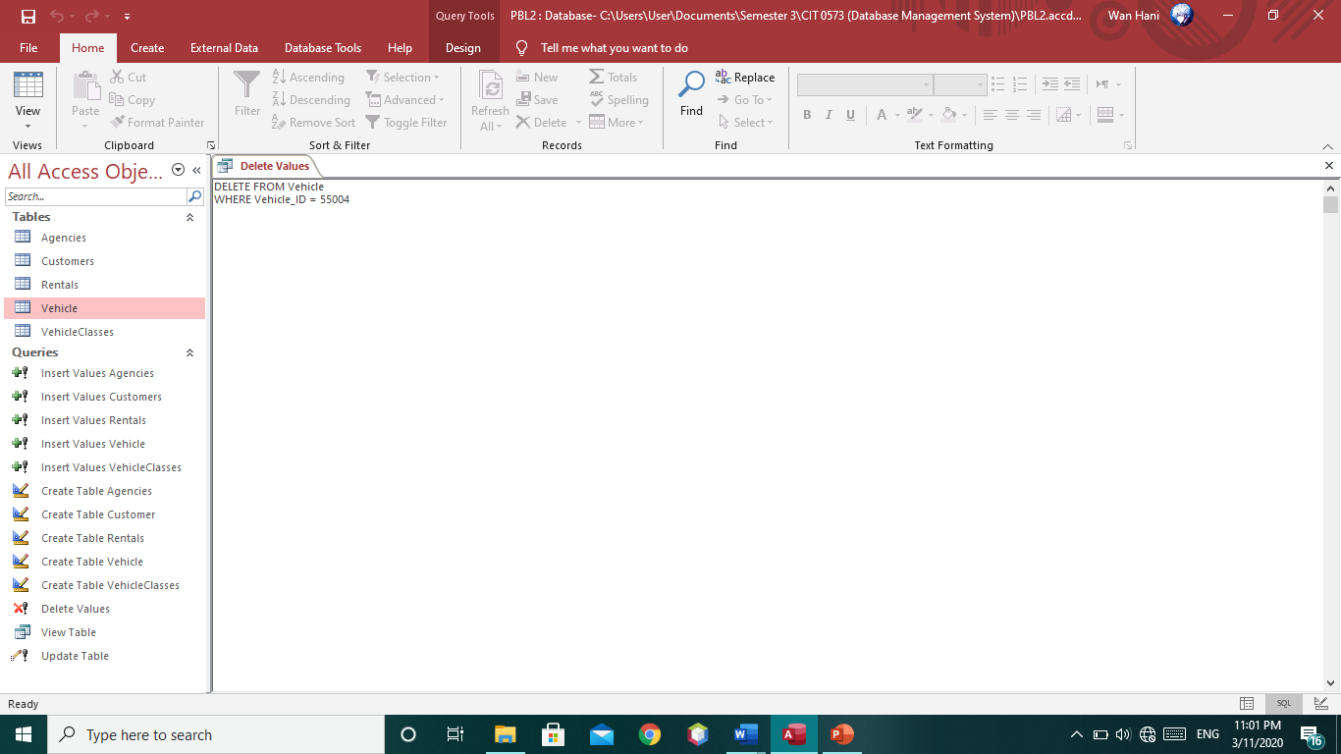

* **Result**

**Before :**

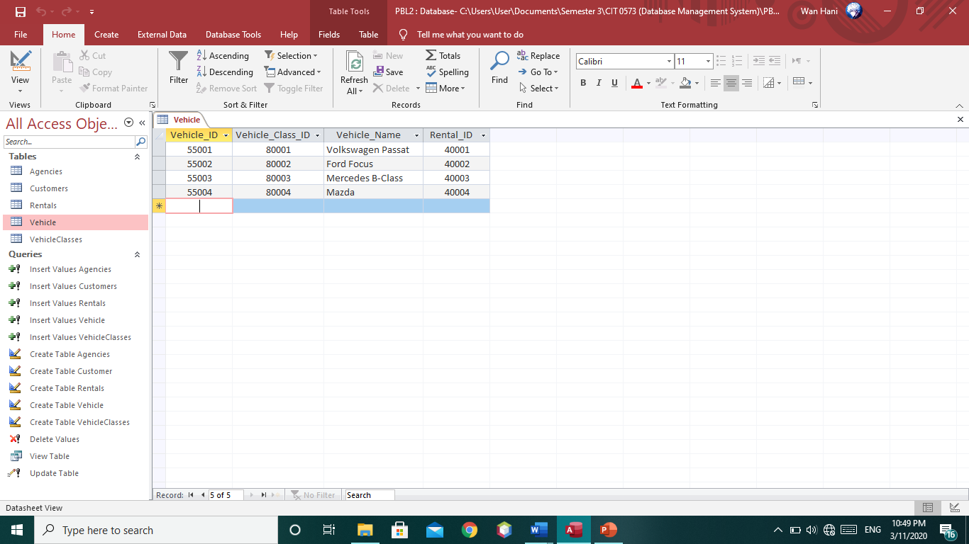

**After :**

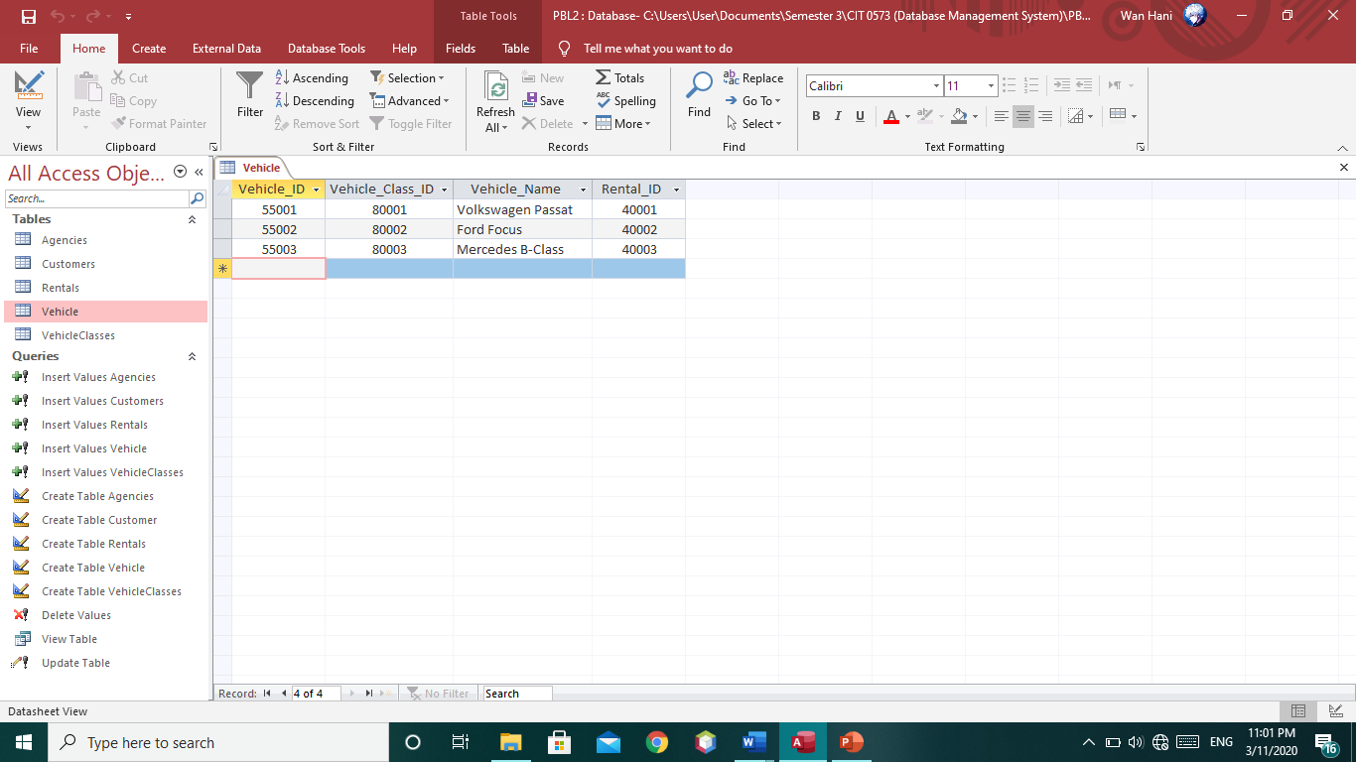

**Screenshot of Create Form & Navigation Form in Microsoft Access**

1. **Create Form**

* **Agencies**

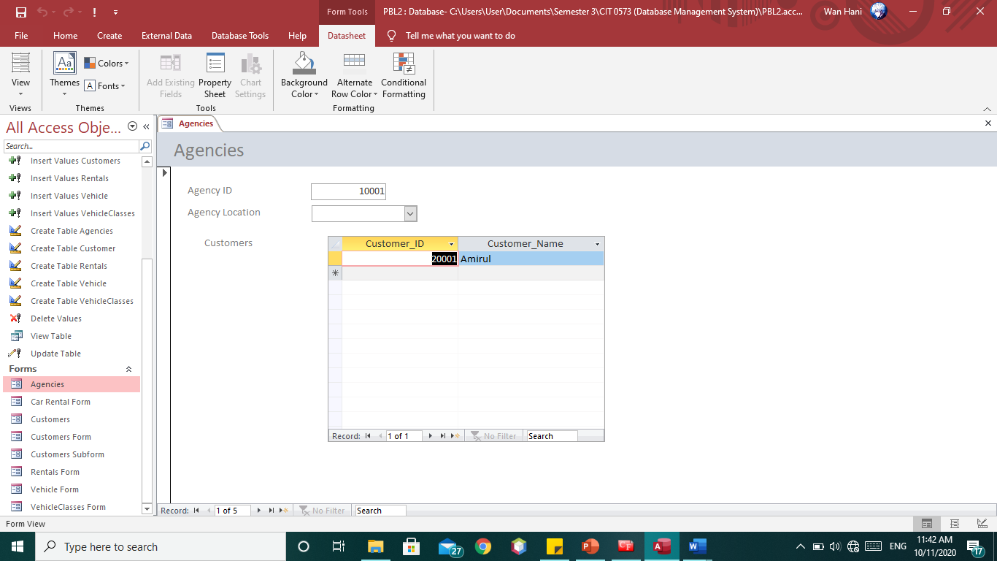

* **Customers**

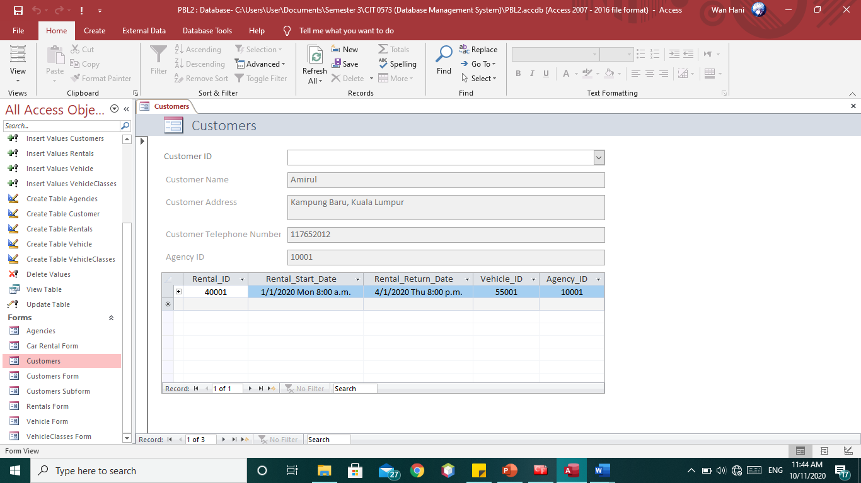

* **Rentals**

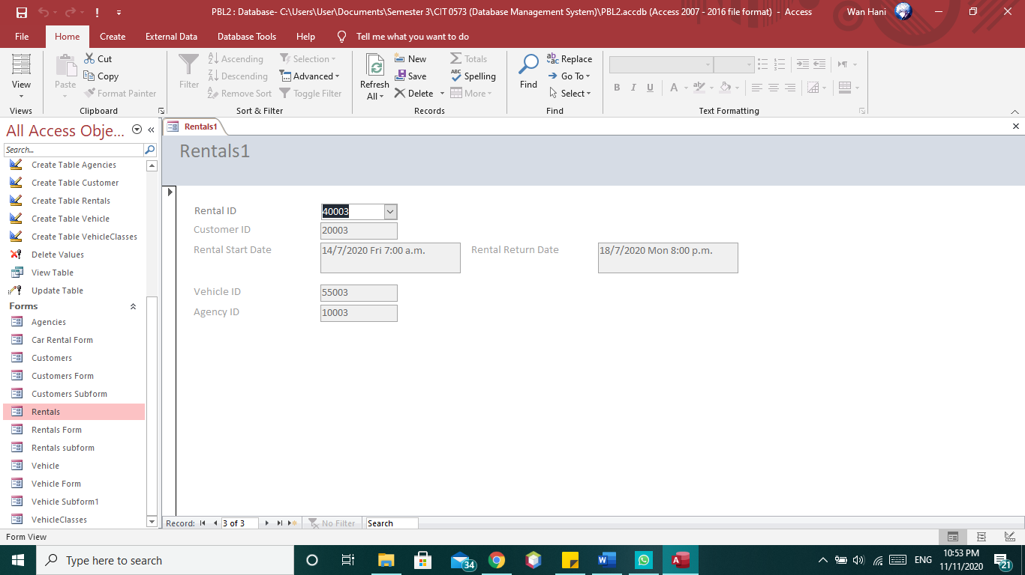

* **Vehicle**

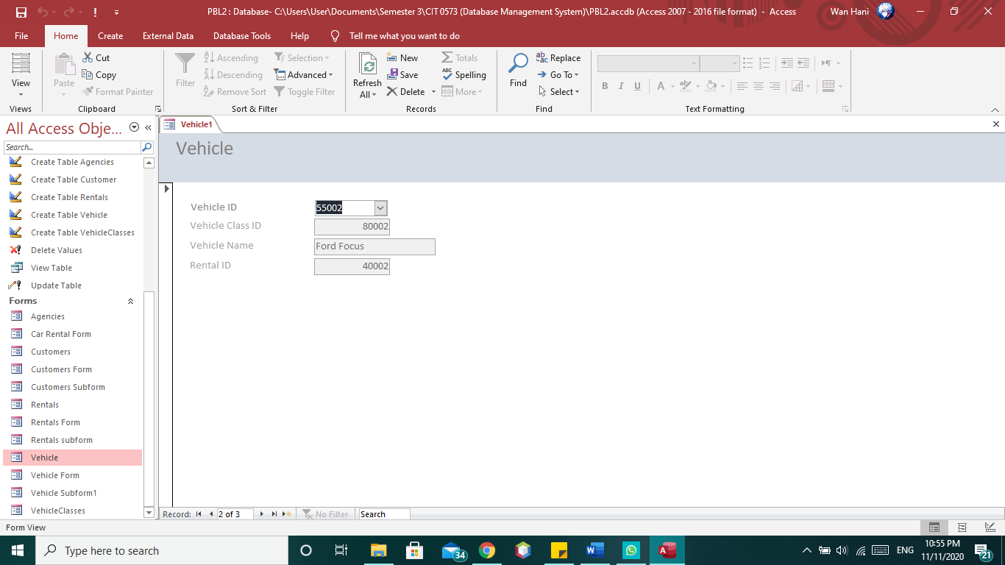

* **Vehicle Classes**

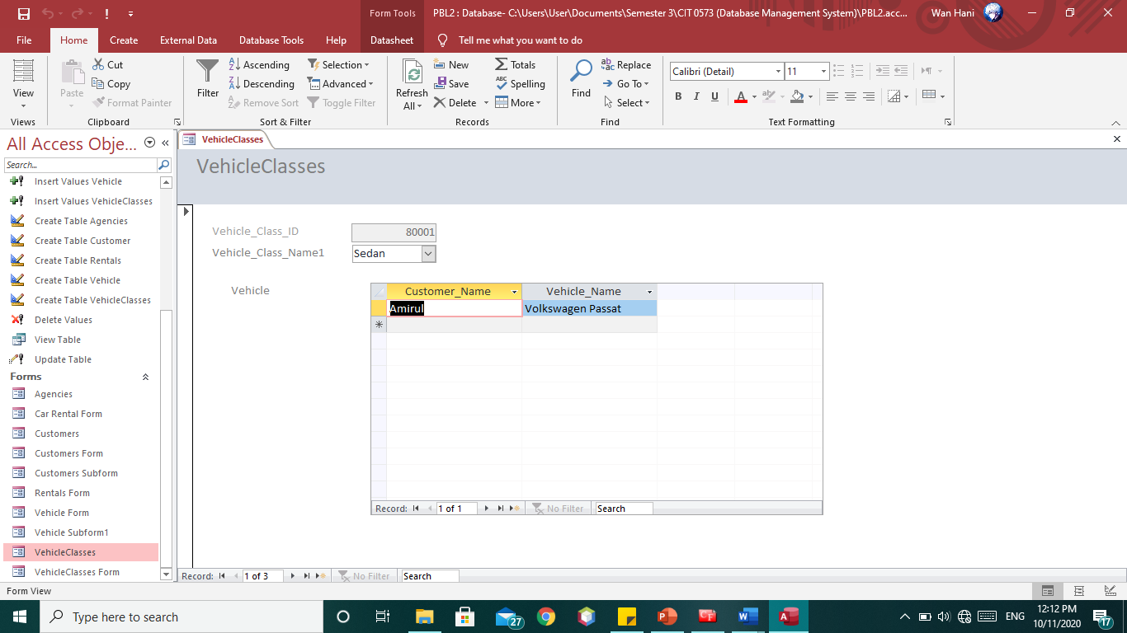

1. **Navigation Form**

* **Agencies**

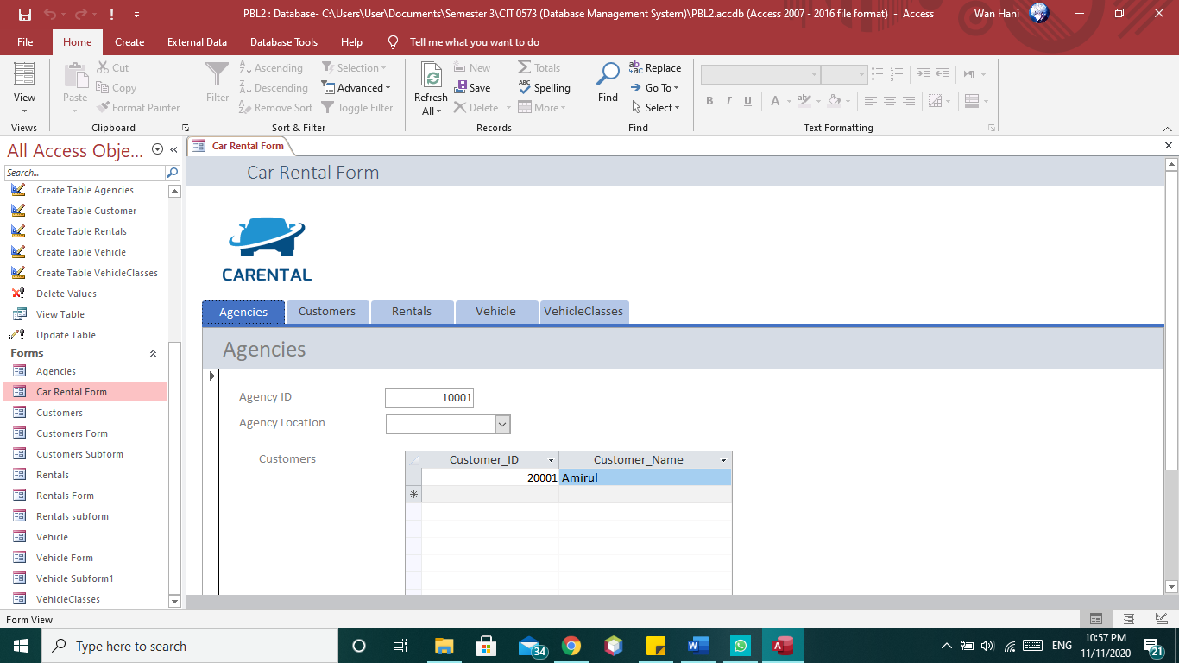

* **Customers**

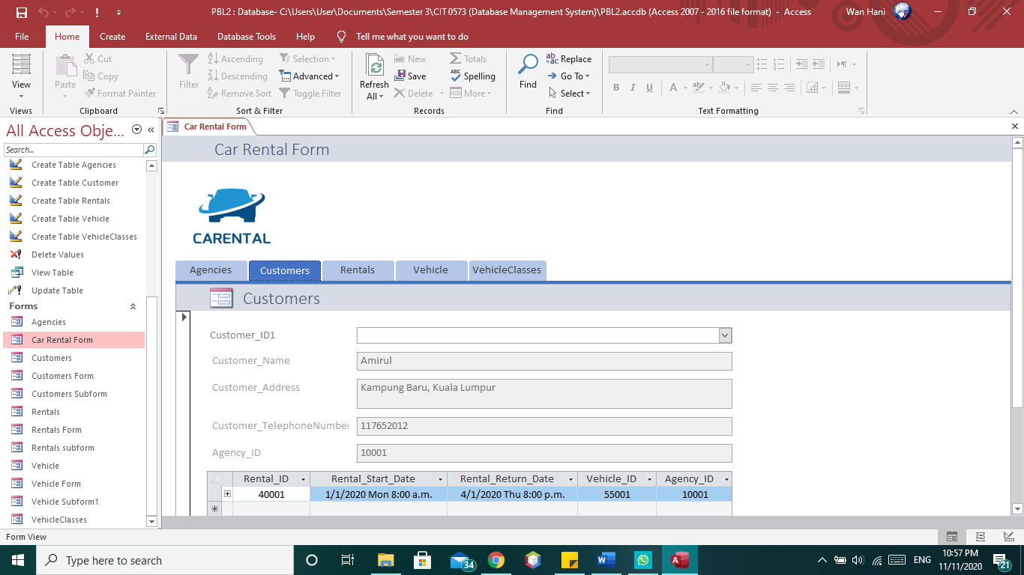

* **Rentals**

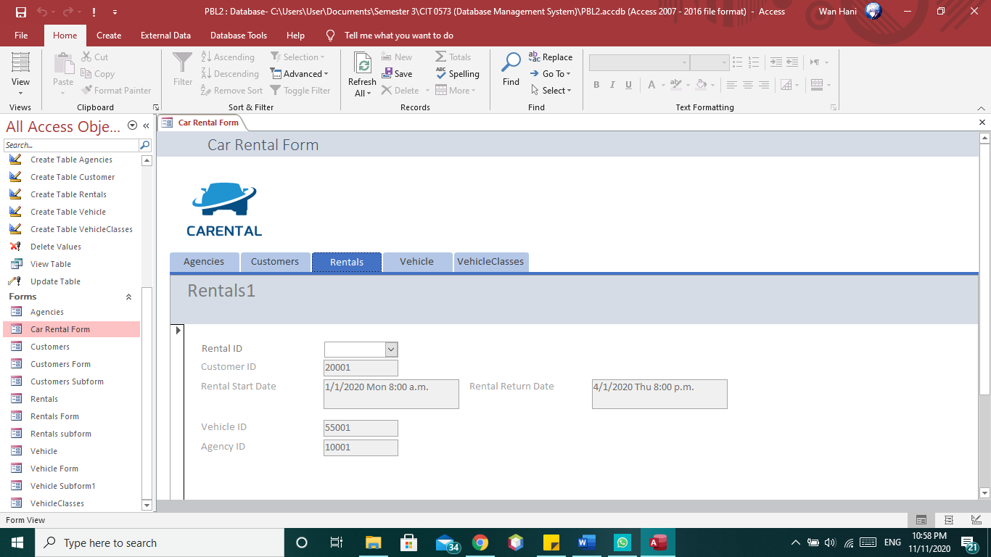

* **Vehicle**

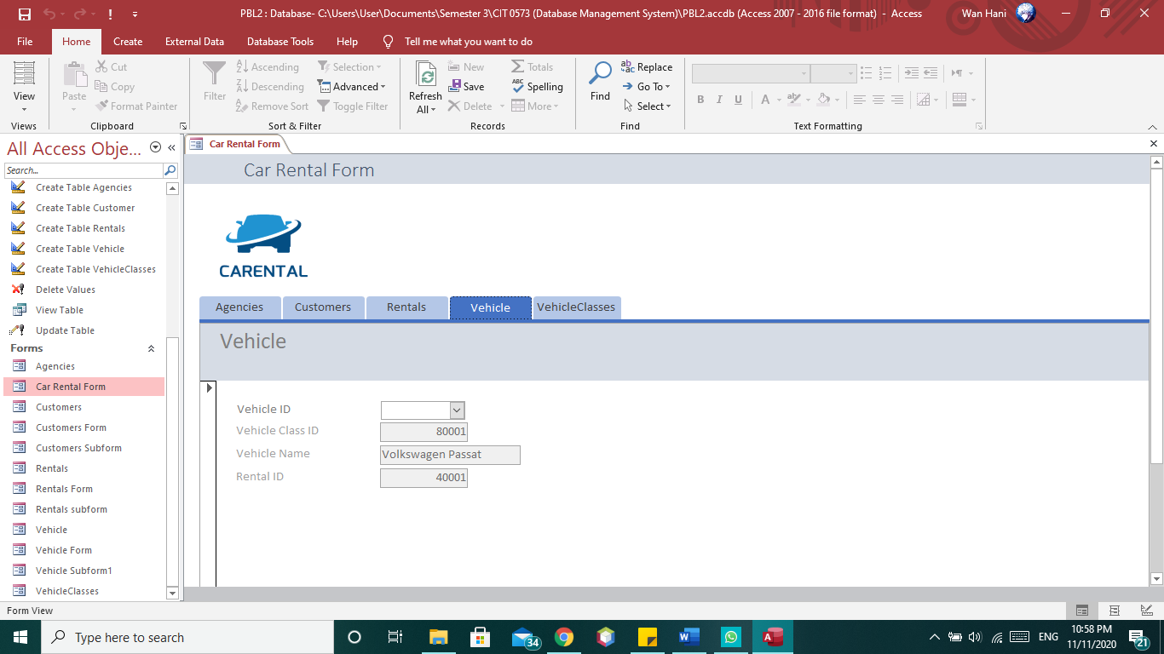

* **Vehicle Classes**

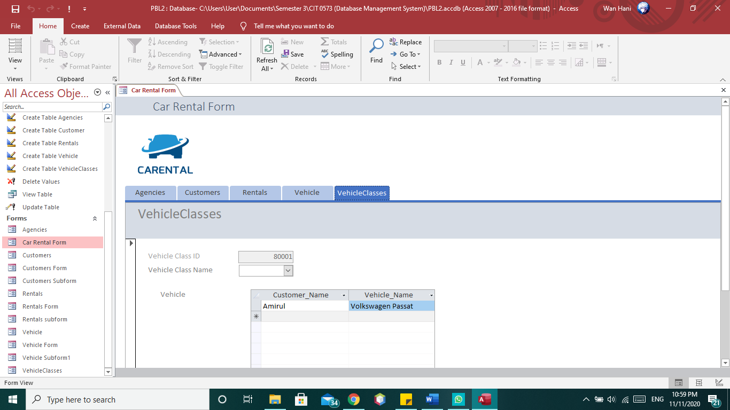

# 

# **Conclusion**

In this conclusion, we know that the car rental system is a company or business that rents cars to students and working people for short periods of time, usually these rents start from a few hours to a day. It is often arranged by many branches or businesses (which allows user to return a vehicle to a different or designated location), and especially located near collage, university, or busy city. The problem that we encountered and need to solve is the in order to offer cars for rent through car rental, a car owner normally have to come to the nearest agencies office to register car to be rent out. To rent a car through car rental, a prospective renter who is interested in renting a car need to go to the nearest agencies office to register as a client with the agencies. Cars that provide difficulties to rent out are normally advertised in local or national newspaper. It involves a lot of paper work and consumes time.

The solution is to improve current system that will allow car owner to register their cars online for rent and will allow database administrator to manage their data fast and efficient . Benefits by using SQL command to manage user data are large amount of data can be retrieve quickly which can increase the speed of database administrator workflow compare to previous workflow. Car rental online system is one of systems that already had been used in our business. It is specialize in car rental services and other services that related to either the owner or the renter.

**References**

|  |  |
| --- | --- |
| [1] | “MS Access Functions,” *W3schools.com*. [Online]. Available: https://www.w3schools.com/sql/sql_ref_msaccess.asp. [Accessed: 11-Nov-2020]. |
| [2] | “SQL UPDATE Statement,” *W3schools.com*. [Online]. Available: https://www.w3schools.com/sql/sql_update.asp. [Accessed: 11-Nov-2020]. |
| [3] | “SQL DELETE Statement,” *W3schools.com*. [Online]. Available: https://www.w3schools.com/sql/sql_delete.asp. [Accessed: 11-Nov-2020]. |
| [4] | “SQL CREATE TABLE Statement,” *W3schools.com*. [Online]. Available: https://www.w3schools.com/sql/sql_create_table.asp. [Accessed: 11-Nov-2020]. |
| [5] | “SQL DROP TABLE Statement,” *W3schools.com*. [Online]. Available: https://www.w3schools.com/sql/sql_drop_table.asp. [Accessed: 11-Nov-2020]. |
| [6] | “SQL ALTER TABLE Statement,” *W3schools.com*. [Online]. Available: https://www.w3schools.com/sql/sql_alter.asp. [Accessed: 11-Nov-2020]. |
| [7] | “SQL CREATE VIEW, REPLACE VIEW, DROP VIEW statements,” *W3schools.com*. [Online]. Available: https://www.w3schools.com/sql/sql_view.asp. [Accessed: 11-Nov-2020]. |
| [8] | GCFLearnFree.org, “Access: Modifying Tables,” 08-Apr-2016. [Online]. Available: https://www.youtube.com/watch?v=mtX2QLrJv1U. [Accessed: 11-Nov-2020]. |
| [9] | StudySpan, “How to Rename and Delete a Table in Microsoft Access,” 25-May-2020. [Online]. Available: https://www.youtube.com/watch?v=LP6sgaMUkV4. [Accessed: 11-Nov-2020]. |
| [10] | Professor Adam Morgan, “Access 2016 - subform Tutorial - how to create subforms in Microsoft Office 365 - add form and forms,” 21-May-2017. [Online]. Available: https://www.youtube.com/watch?v=xPQdfZbqCQk. [Accessed: 11-Nov-2020]. |
| [11] | Tutorials Point (India) Ltd., “MS Access 2016 - Enhance Navigation of forms,” 04-Jan-2018. [Online]. Available: https://www.youtube.com/watch?v=fCnFqcWfB-o. [Accessed: 11-Nov-2020]. |
| [12] | mrhunterict, “Adding a checkbox to the main form,” 10-Feb-2009. [Online]. Available: https://www.youtube.com/watch?v=Qsbg7YSfm5U. [Accessed: 11-Nov-2020]. |
| [13] | Professor Adam Morgan, “Access 2016 - creating forms - new record button - how to add delete design and modify a form in MS,” 19-Nov-2017. [Online]. Available: https://www.youtube.com/watch?v=maly8s-CfFg. [Accessed: 11-Nov-2020]. |
| [14] | Kirt Kershaw, “Microsoft Access 2016 forms: Combo Box,” 31-Dec-2018. [Online]. Available: https://www.youtube.com/watch?v=rtBkJ7XotUo. [Accessed: 11-Nov-2020]. |
| [15] | Sali Kaceli, “Creating forms in Access 2010,” 12-Apr-2012. [Online]. Available: https://www.youtube.com/watch?v=GXML5L1OaZI. [Accessed: 11-Nov-2020]. |